**Team 10**

**Ashish Shinde (NUID: 002199940)**

**Disha Vaswani (NUID: 002142071)**

**Question 1:**

**1. Use Big Query Public datasets (6/1/2013-5/31/2018)**

**Trends and Analysis:**

Number of rows count

SELECT count(*) as Number_of_Rows FROM `bigquery-public-data.new_york_citibike.citibike_trips` LIMIT 1000;

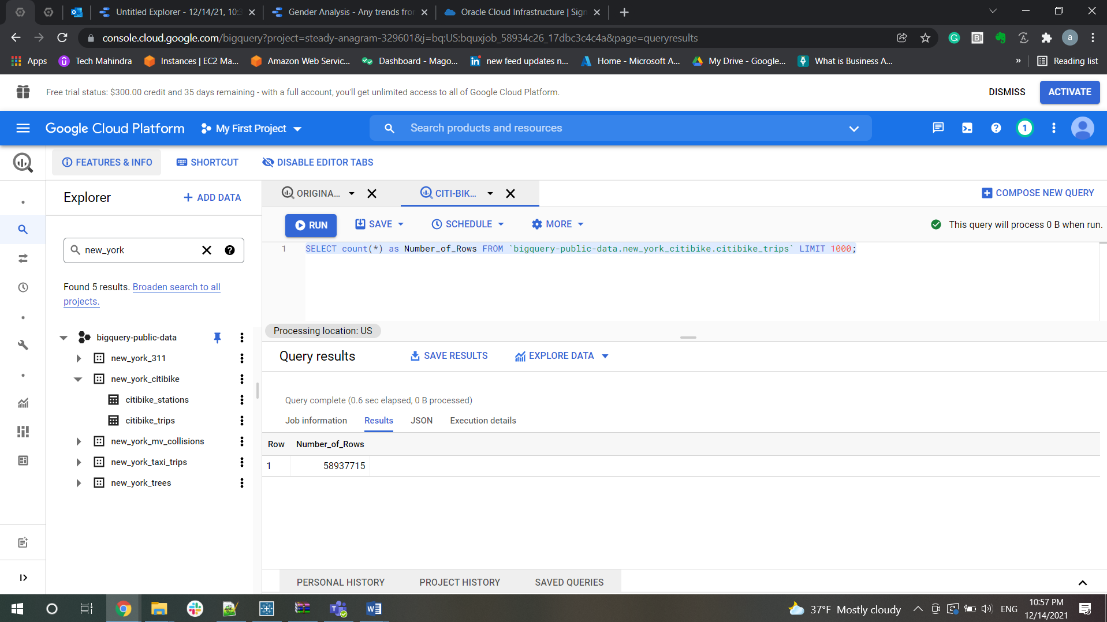

• How many bike trips and what is the trend over time

▪ calendar year (2017)

SELECT count(*) as number_of_trips, EXTRACT(YEAR FROM starttime) AS year,

EXTRACT(MONTH  FROM starttime) AS MONTH  from `bigquery-public-data.new_york_citibike.citibike_trips`

group by year, MONTH

having year = 2017

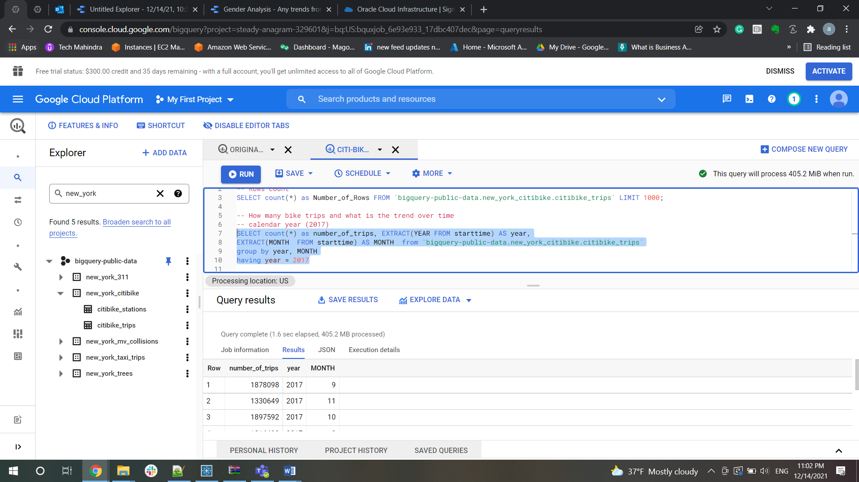

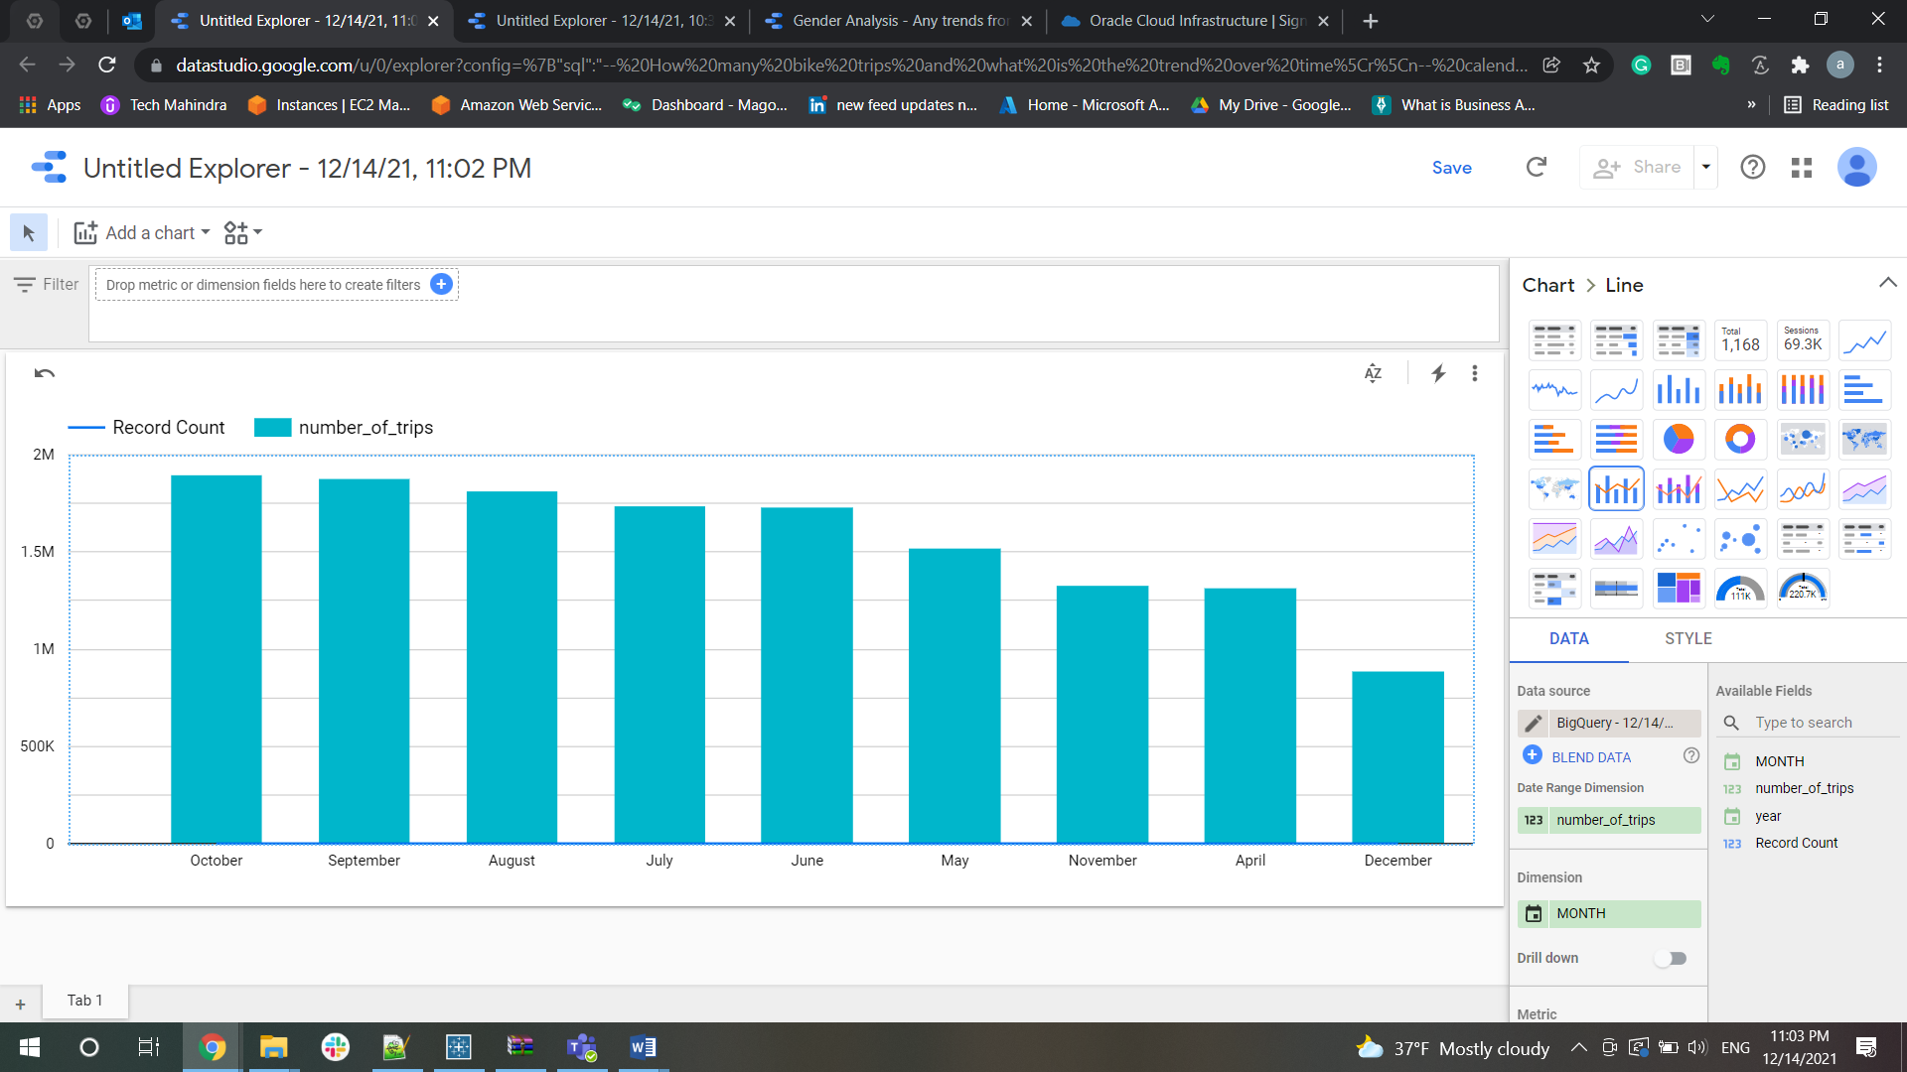

**As per analysis, for year 2017 maximum trips were in the month of October**

▪ calendar month & year (2017-09)

SELECT count(*) as number_of_trips, EXTRACT(YEAR FROM starttime) AS year,

EXTRACT(MONTH  FROM starttime) AS MONTH,EXTRACT(WEEK  FROM starttime) AS WEEK  from `bigquery-public-data.new_york_citibike.citibike_trips`

group by year, MONTH,WEEK

having (year = 2017 and MONTH=9)

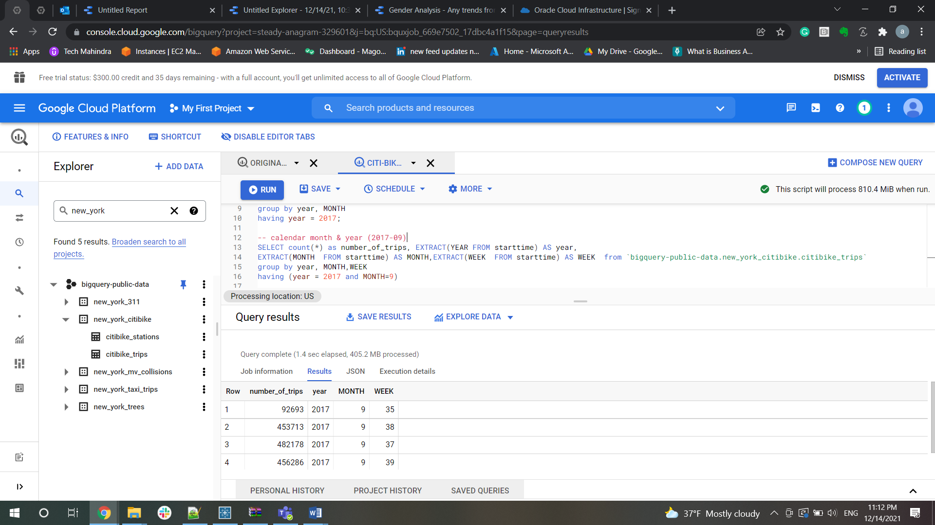

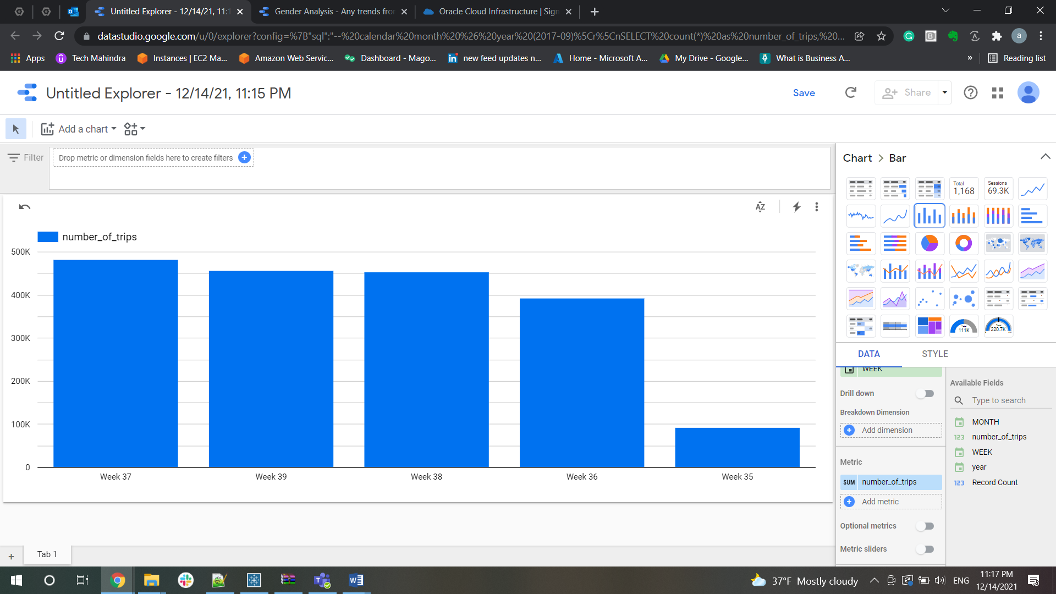

**As per analysis, for year 2017 and month 09 (September) maximum trips were in the week 37**

▪ calendar week (2017-36)

--calendar week (2017-36)

SELECT count(*) as number_of_trips, EXTRACT(YEAR FROM starttime) AS year,

EXTRACT(MONTH  FROM starttime) AS MONTH,EXTRACT(WEEK  FROM starttime) AS WEEK, EXTRACT(DAY  FROM starttime) AS DAY  from `bigquery-public-data.new_york_citibike.citibike_trips`

group by year, MONTH,WEEK,DAY

having (year = 2017 and MONTH=9 and WEEK=36);

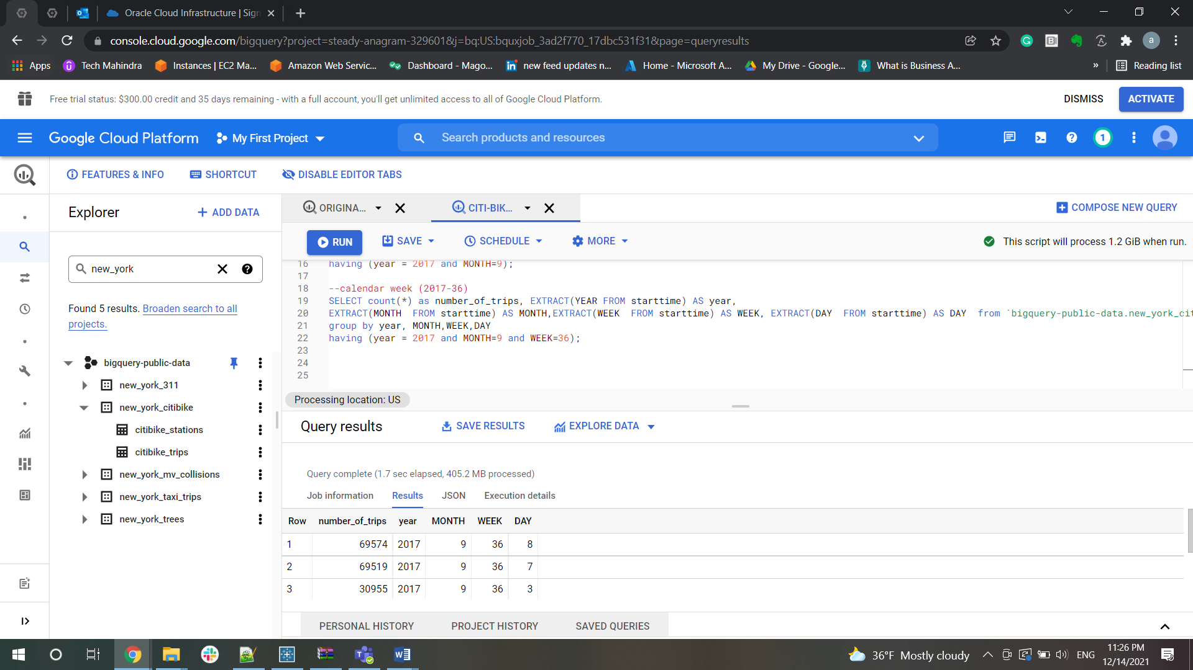

▪ calendar day (2017-09-01)

-- calendar day (2017-09-01)

SELECT count(*) as number_of_trips, EXTRACT(YEAR FROM starttime) AS year,

EXTRACT(MONTH  FROM starttime) AS MONTH,EXTRACT(WEEK  FROM starttime) AS WEEK,

EXTRACT(DAY  FROM starttime) AS DAY,

EXTRACT(HOUR FROM starttime) AS HOUR

from `bigquery-public-data.new_york_citibike.citibike_trips`

group by year, MONTH,WEEK,DAY,HOUR

having (year = 2017 and MONTH=9 AND DAY=1);

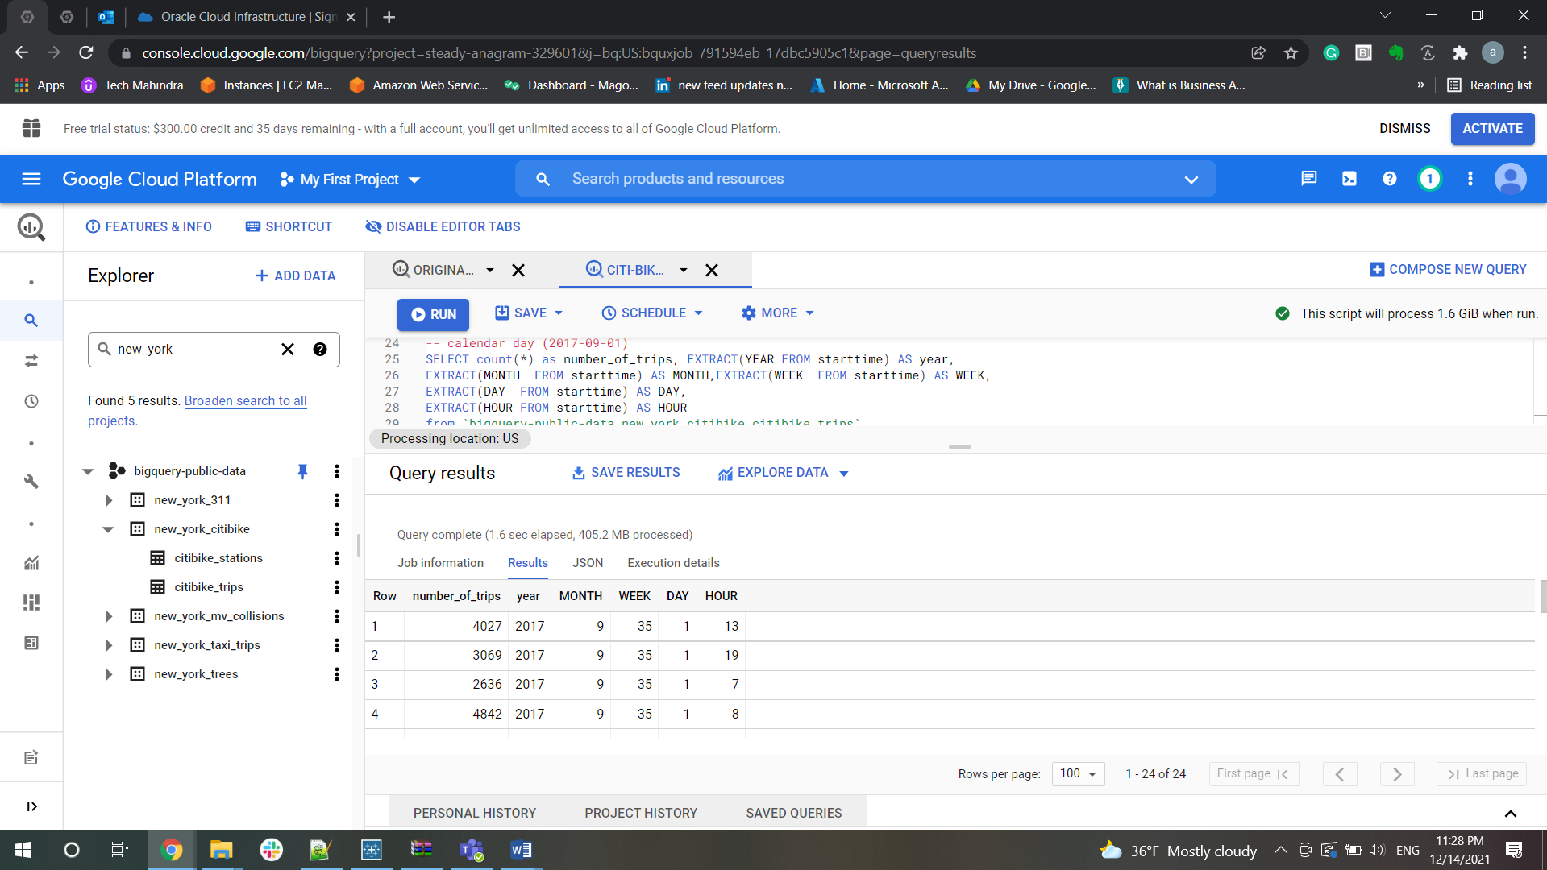

Examining when trips occur during the day

• How many bike trips occur during what periods of the day:  
▪ By hour (0900, 1300)

SELECT EXTRACT(HOUR from starttime) as hour, count(*) as biketrips

from `bigquery-public-data.new_york_citibike.citibike_trips`

where (starttime > '2013-06-01' and  starttime < '2021-12-07')

group by hour

order by hour;

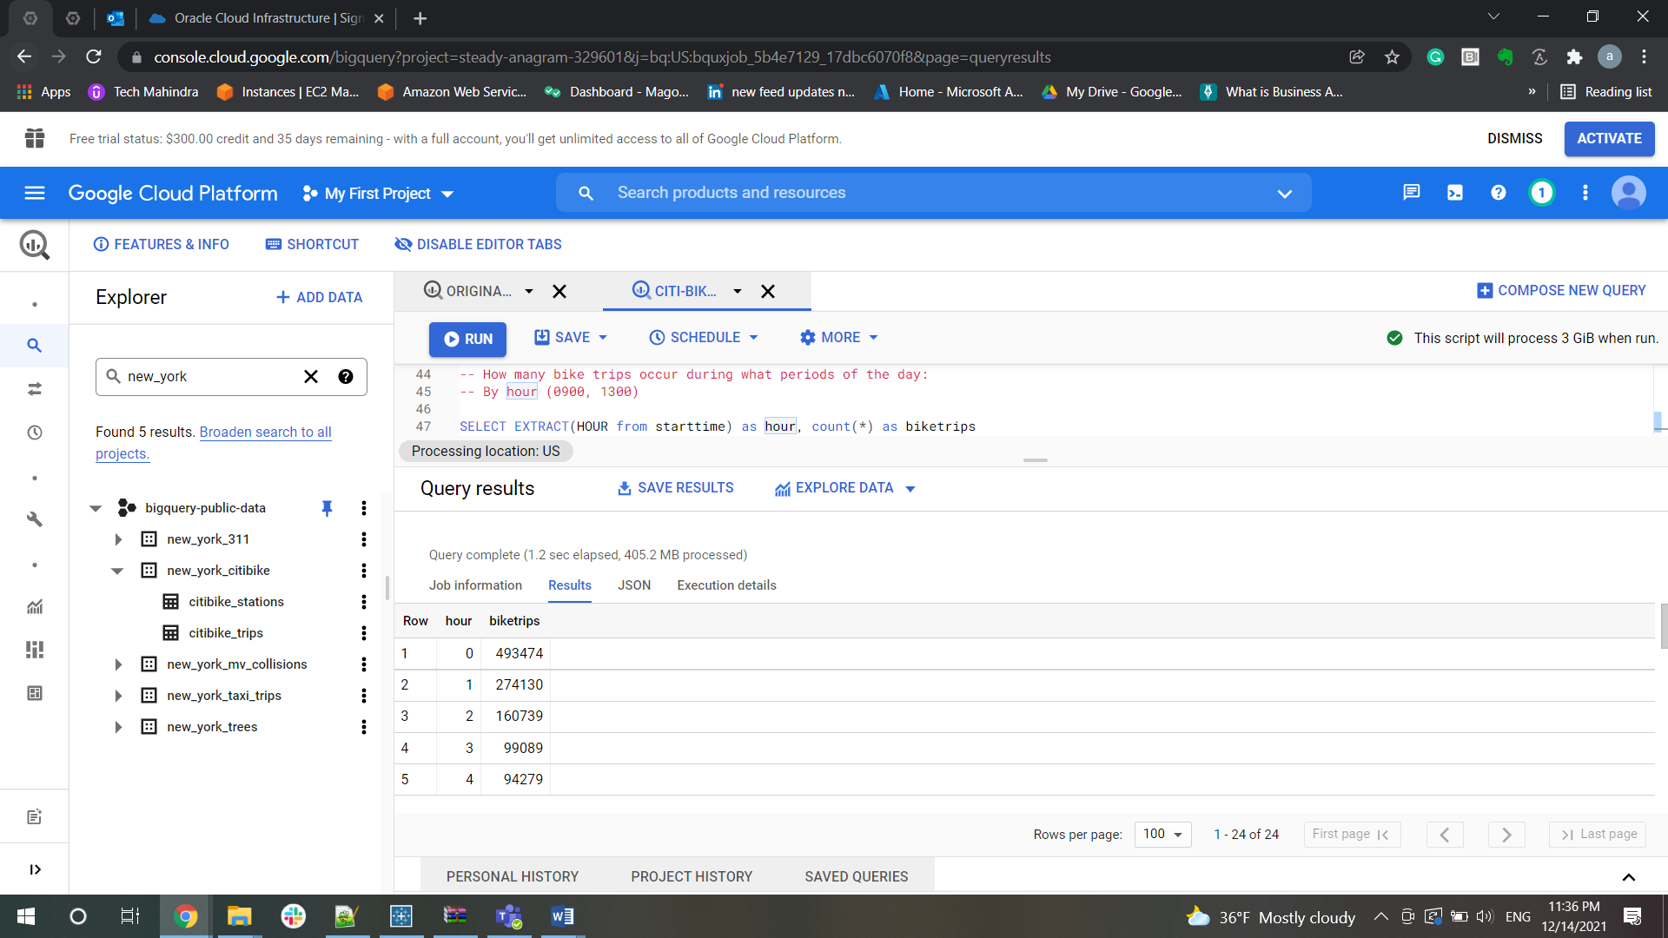

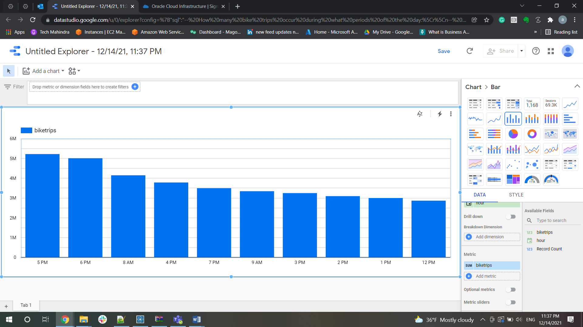

**As per analysis, Maximum trips occurred on 5 PM of the day**

▪ During periods during the day i.e., morning 6am-11:59am, afternoon noon-5:59pm, evening   
6pm-10pm

SELECT (select count(*) as common_trip from `bigquery-public-data.new_york_citibike.citibike_trips` where start_station_name = end_station_name) as round,

(select count(*) as diff_trip from `bigquery-public-data.new_york_citibike.citibike_trips` where start_station_name != end_station_name) as nonround

from `bigquery-public-data.new_york_citibike.citibike_trips` group by round,nonround;

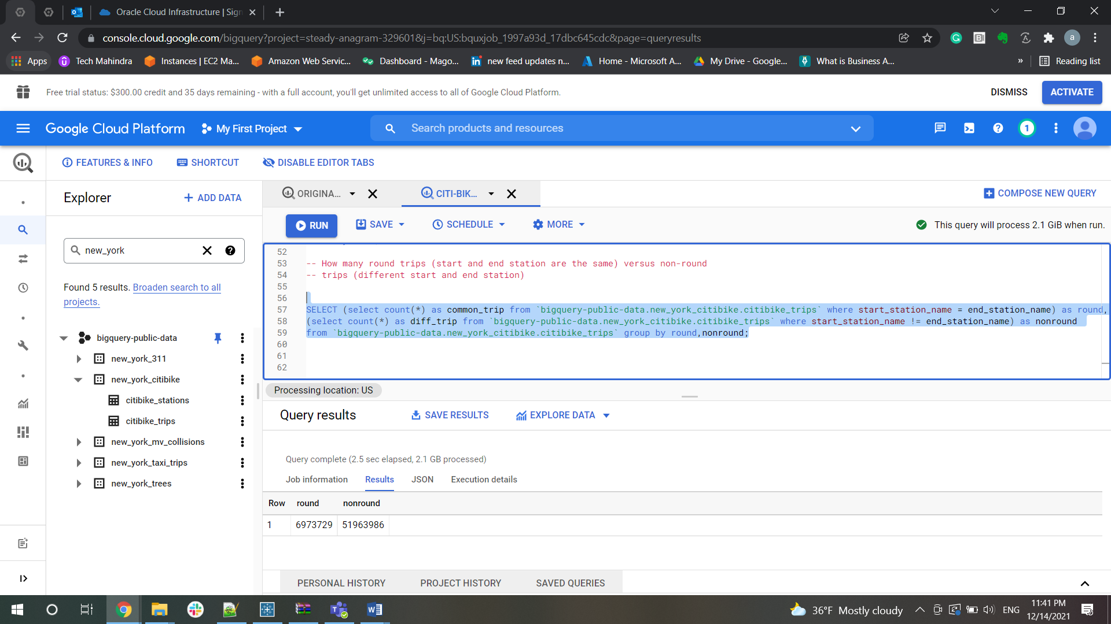

• How many round trips (start and end station are the same) versus non-round   
trips (different start and end station)

SELECT (select count(*) as common_trip from `bigquery-public-data.new_york_citibike.citibike_trips` where start_station_name = end_station_name) as round,(select count(*) as diff_trip from `bigquery-public-data.new_york_citibike.citibike_trips` where start_station_name != end_station_name) as nonround from `bigquery-public-data.new_york_citibike.citibike_trips` group by round,nonround;

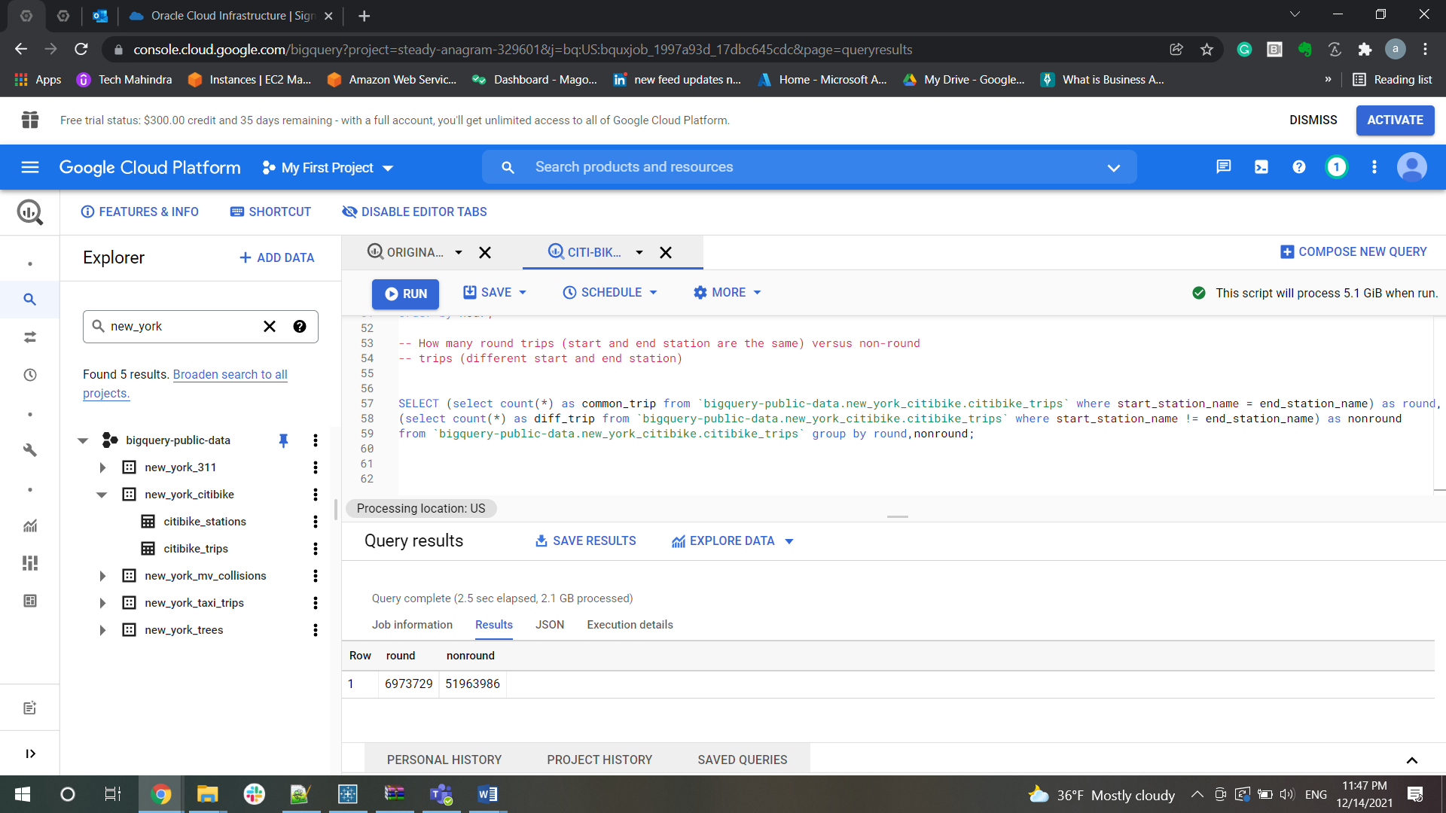

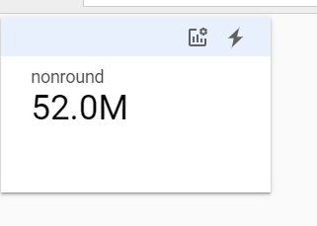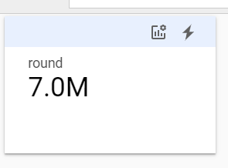

▪ Further breakdown subscriber vs customer

-- Further breakdown subscriber vs customer

SELECT (select count(*) as common_trip from `bigquery-public-data.new_york_citibike.citibike_trips` where start_station_name = end_station_name) as round,

(select count(*) as diff_trip from `bigquery-public-data.new_york_citibike.citibike_trips` where start_station_name != end_station_name) as nonround , usertype

from `bigquery-public-data.new_york_citibike.citibike_trips` group by round,nonround, usertype;

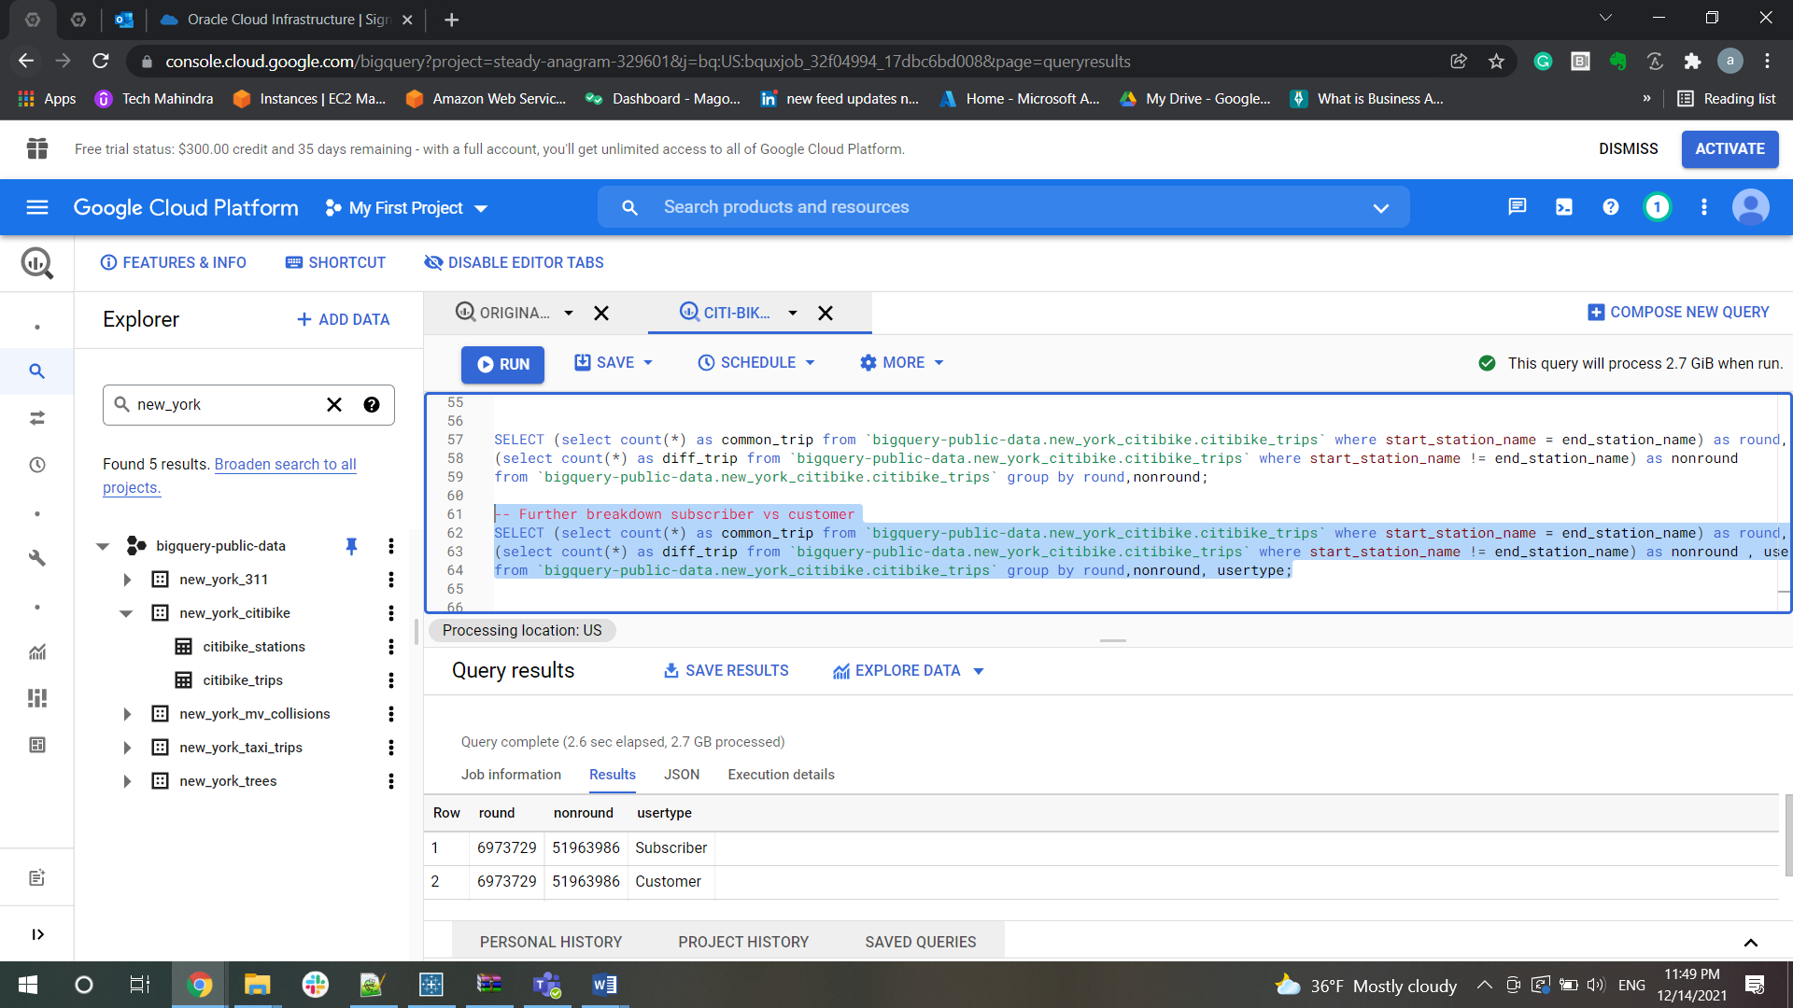

▪ Average length of trip

SELECT (select count(*) as common_trip from `bigquery-public-data.new_york_citibike.citibike_trips` where start_station_name = end_station_name) as round, (select count(*) as diff_trip from `bigquery-public-data.new_york_citibike.citibike_trips` where start_station_name != end_station_name) as nonround , usertype, avg(tripduration) as tripduration from `bigquery-public-data.new_york_citibike.citibike_trips` group by round,nonround, usertype;

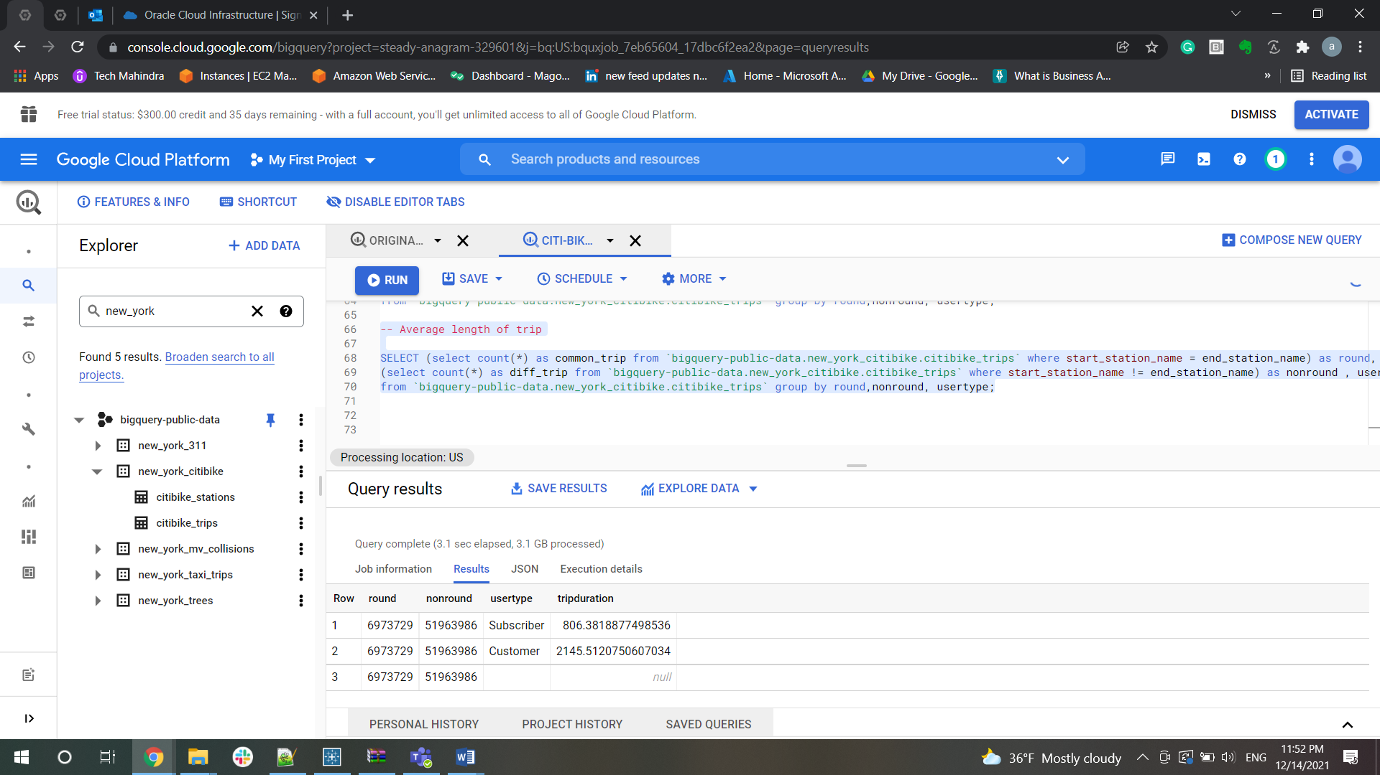

Examining length of trips

Length of trips (in time)\  
▪ What is the average length (in minutes) of bike trip?

SELECT avg(tripduration / 60) as Average_Trip FROM `bigquery-public-data.new_york_citibike.citibike_trips` where (starttime > '2013-06-01' and starttime < '2021-12-07');

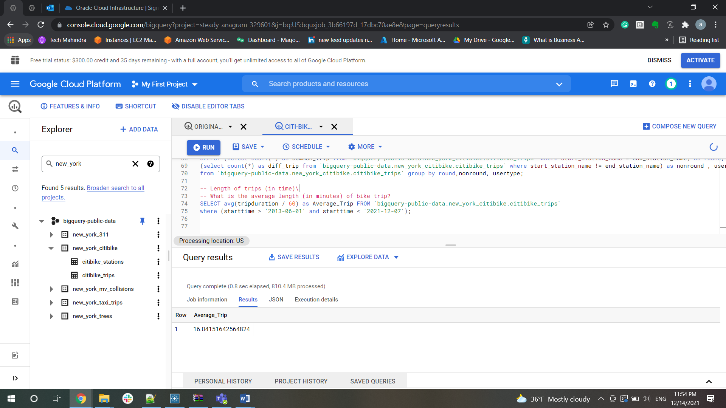

oFurther breakdown by subscriber versus customer

* Grouped by Subscriber

SELECT avg(tripduration / 60) as Average_Trip FROM `bigquery-public-data.new_york_citibike.citibike_trips`

where usertype='Subscriber'

and (starttime > '2013-06-01' AND starttime < '2021-12-07');

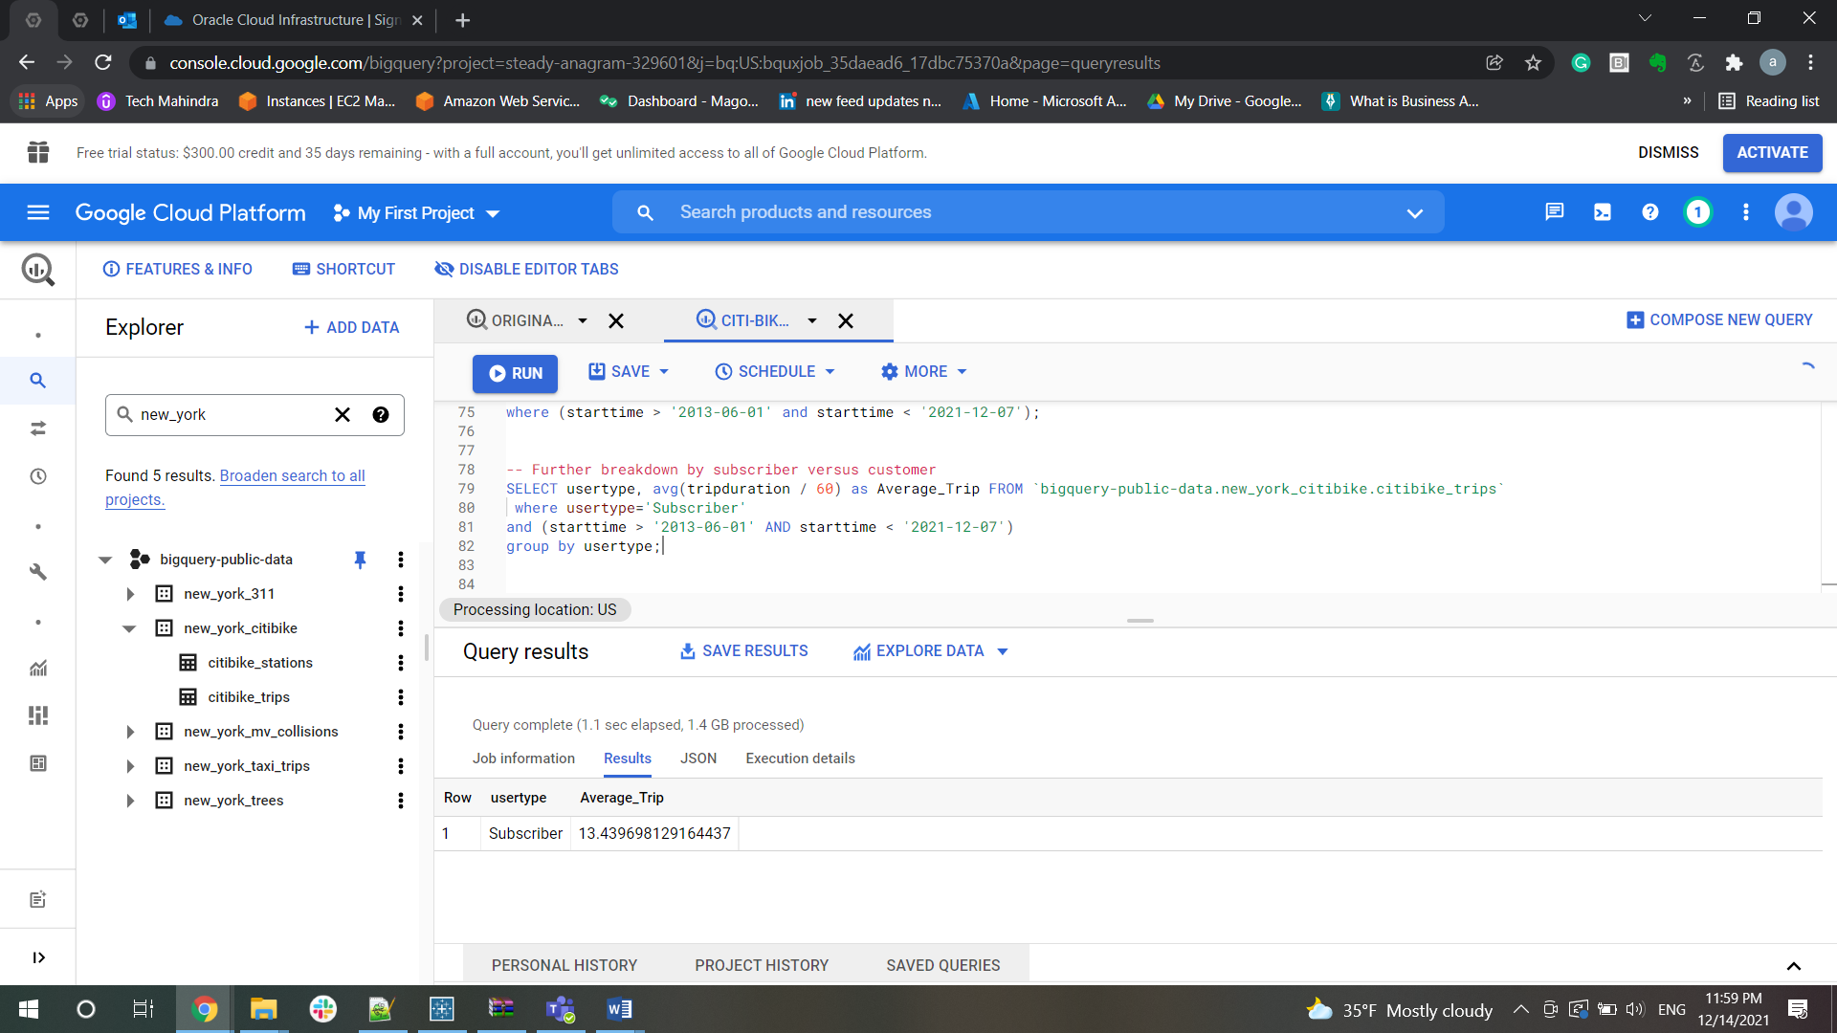

Grouped by Customer

SELECT avg(tripduration / 60) as Average_Trip FROM `bigquery-public-data.new_york_citibike.citibike_trips`

where usertype='Customer' and (starttime > '2013-06-01' AND starttime < '2021-12-07');

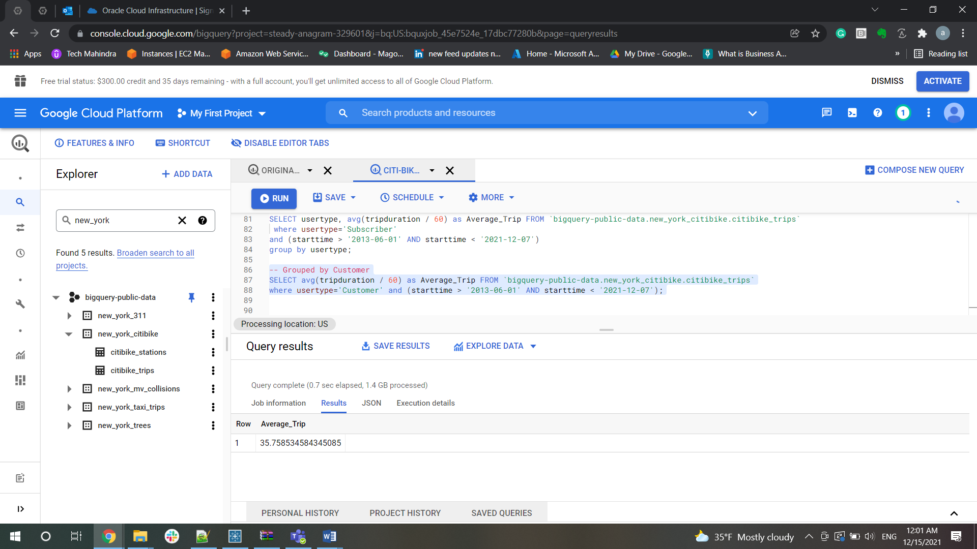

How many trips are less than 15 minutes in duration?

select count(*) as count from `bigquery-public-data.new_york_citibike.citibike_trips`

where (starttime > '2013-06-01' and starttime < '2021-12-07') and (tripduration/60) < 15;

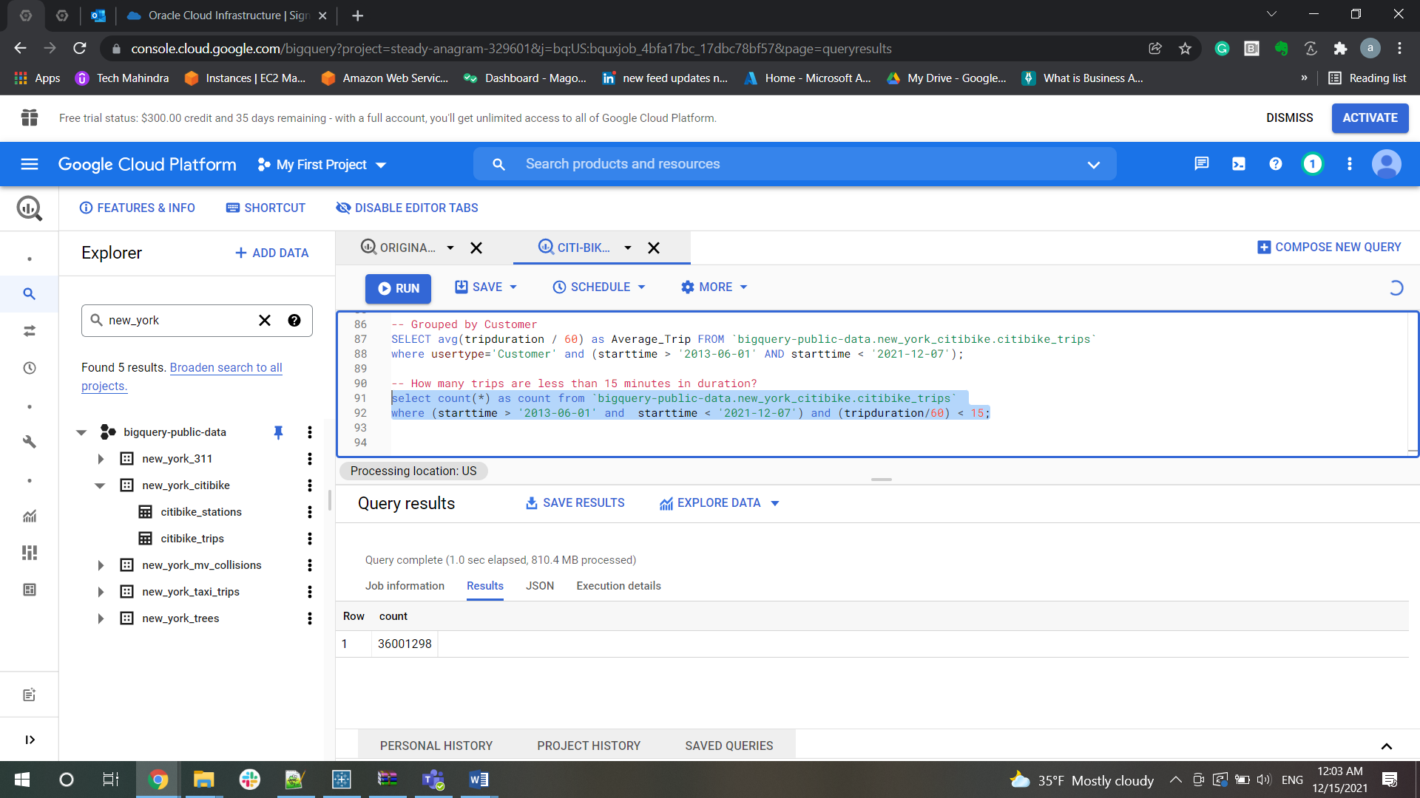

How many trips are greater than 15 minutes but less than 1 hour in duration?

select count(*) as no_of_trips from `bigquery-public-data.new_york_citibike.citibike_trips`

where (tripduration/60) > 15 and (tripduration/60) < 60 and (starttime > '2013-06-01' and starttime < '2021-12-07');

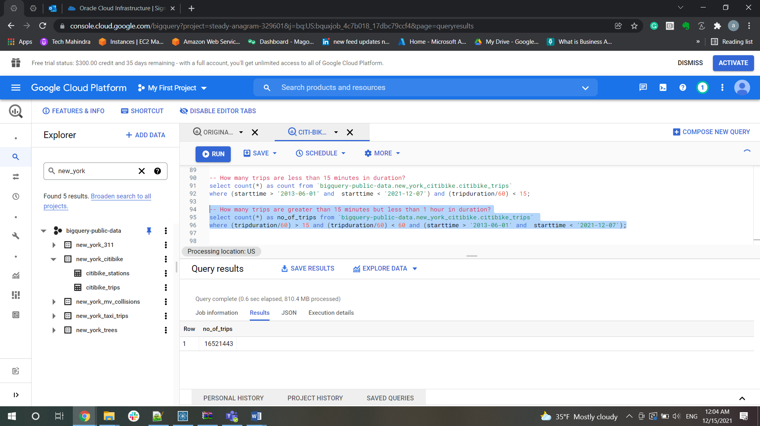

How many trips are greater than 1 hour in duration?

SELECT count(*) as no_of_trips FROM `bigquery-public-data.new_york_citibike.citibike_trips`

where (tripduration / 60) > 60 and (starttime > '2013-06-01' and starttime < '2021-12-07');

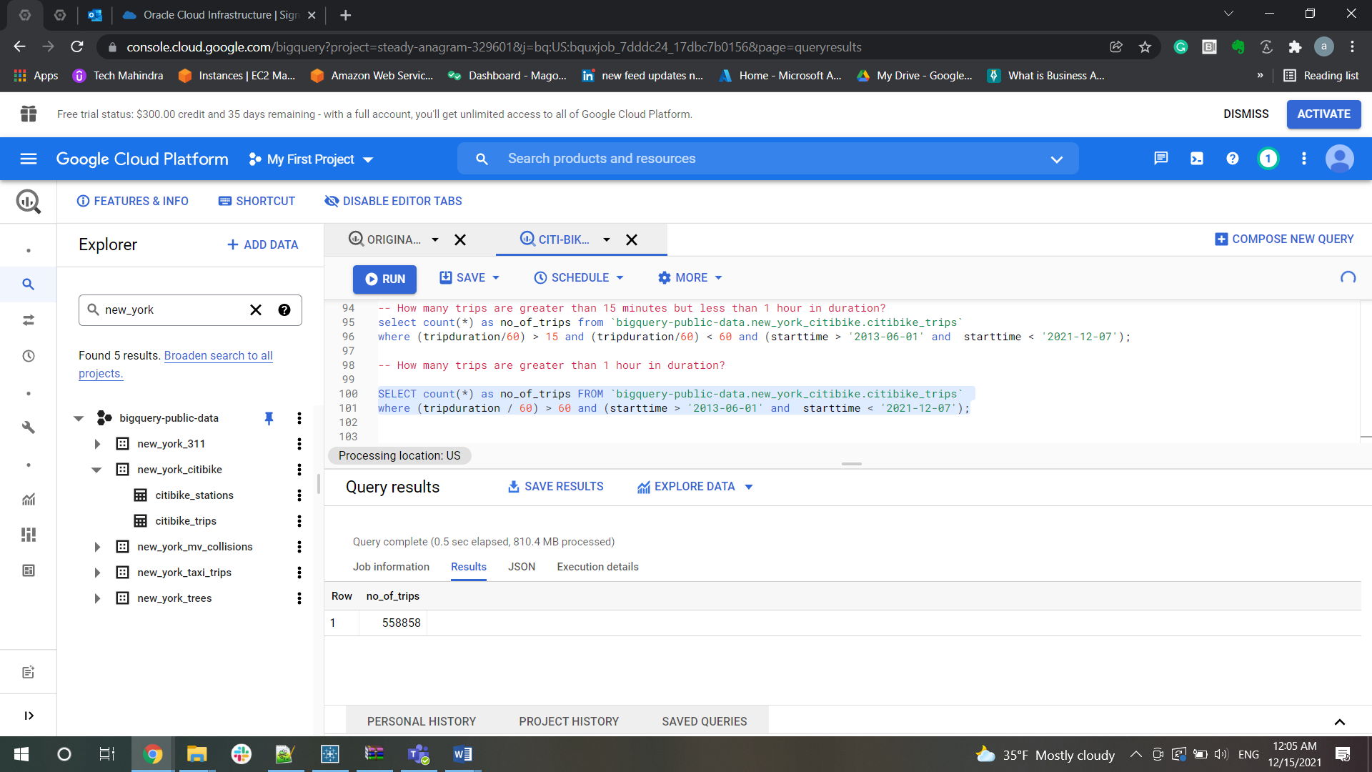

Most popular stations

• What are the top 10 bike stations based on bike trips?   
▪ For staring a trip

SELECT start_station_id,start_station_name, count(station_id) as no_of_trips FROM `bigquery-public-data.new_york_citibike.citibike_stations`

inner join `bigquery-public-data.new_york_citibike.citibike_trips`

on Station_id = start_station_id

where (starttime > '2013-06-01' and starttime < '2021-12-07')

group by start_station_id, start_station_name

order by count(start_station_id) desc

limit 10;

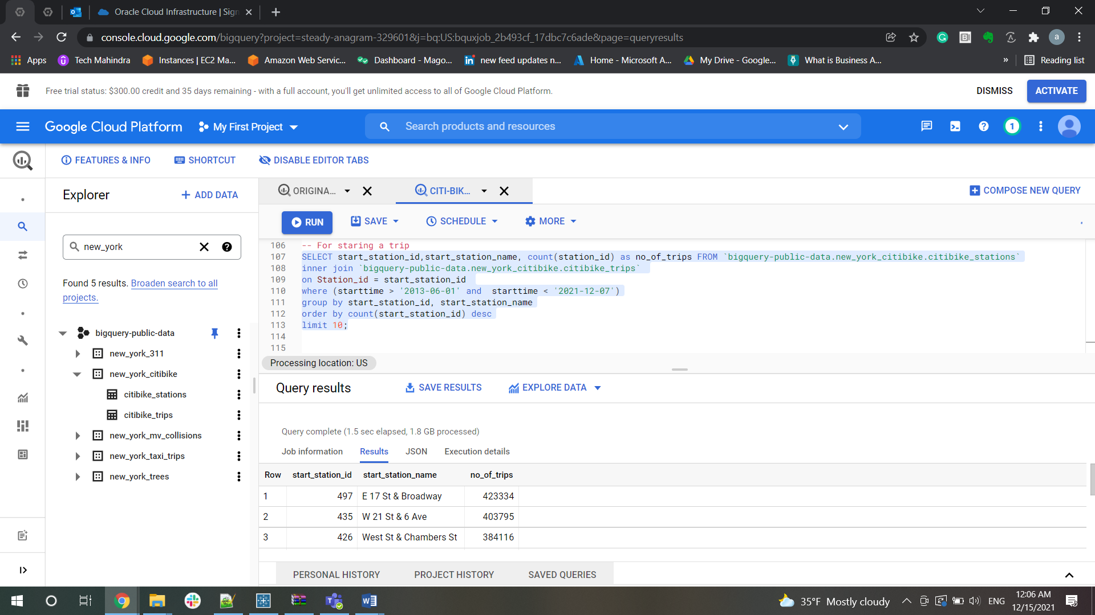

▪ As a trip destination

SELECT end_station_id, end_station_name, count(end_station_id) as no_of_trips FROM `bigquery-public-data.new_york_citibike.citibike_stations`

inner join `bigquery-public-data.new_york_citibike.citibike_trips`

on Station_id = end_station_id

where (starttime > '2013-06-01' and  starttime < '2021-12-07')

group by end_station_id, end_station_name

order by count(end_station_id) desc

limit 10;

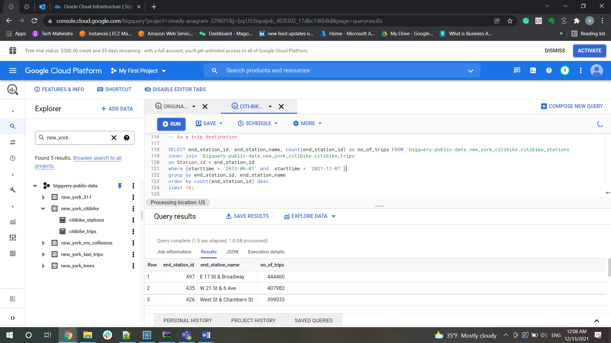

▪ Overall, as ether a start and/or destination

-- Overall, as ether a start and/or destination

SELECT station_id, count(station_id) as no_of_trips FROM `bigquery-public-data.new_york_citibike.citibike_stations`

inner join `bigquery-public-data.new_york_citibike.citibike_trips`

on Station_id = start_station_id

where (starttime > '2013-06-01' and  starttime < '2021-12-07')

group by station_id

order by count(start_station_id + end_station_id) desc

limit 10;

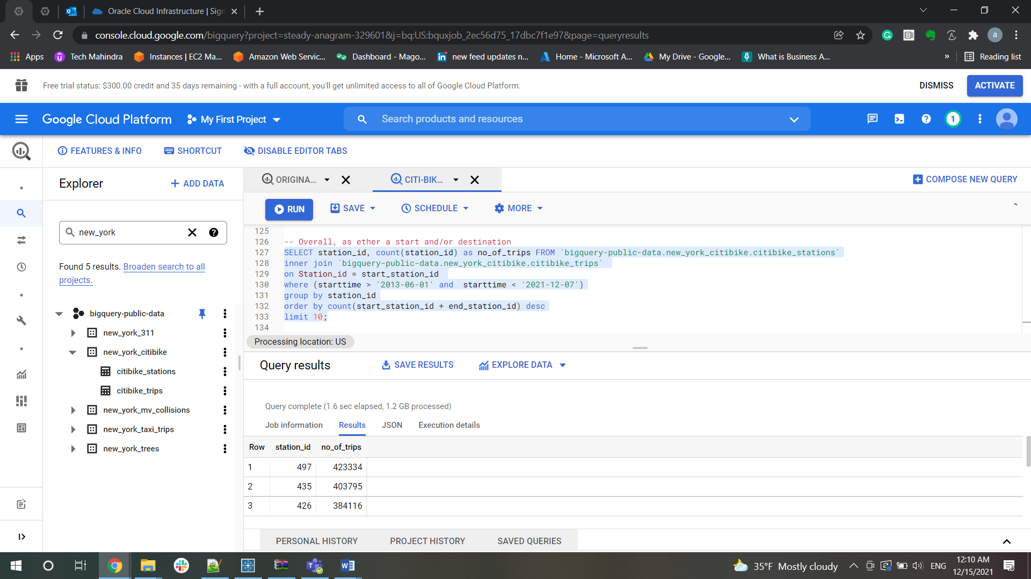

Determine the most popular routes (staring to end location)  
▪ Total number of trips

 select count(*) as no_of_trips from `bigquery-public-data.new_york_citibike.citibike_stations`

 inner join `bigquery-public-data.new_york_citibike.citibike_trips`

 on Station_id = start_station_id

 and Station_id = end_station_id

 where (starttime > '2013-06-01' and  starttime < '2021-12-07')

 order by no_of_trips desc;

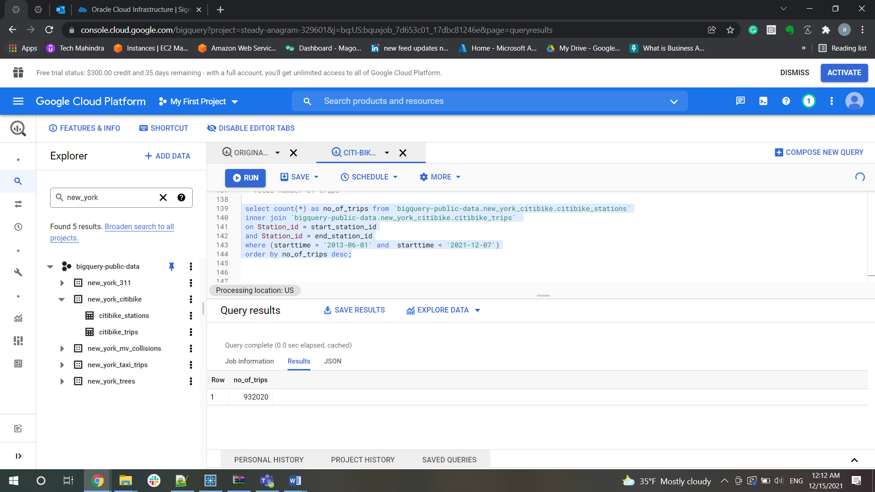

Total number of trips by subscriber and customer

 select count(*) as no_of_trips, u.usertype from `bigquery-public-data.new_york_citibike.citibike_stations`

 inner join `bigquery-public-data.new_york_citibike.citibike_trips` as u

 on Station_id = start_station_id

 and Station_id = end_station_id

 where u.usertype in ('Subscriber','Customer')

 and (starttime > '2013-06-01' and  starttime < '2021-12-07')

 group by u.usertype

 order by no_of_trips desc,no_of_trips;

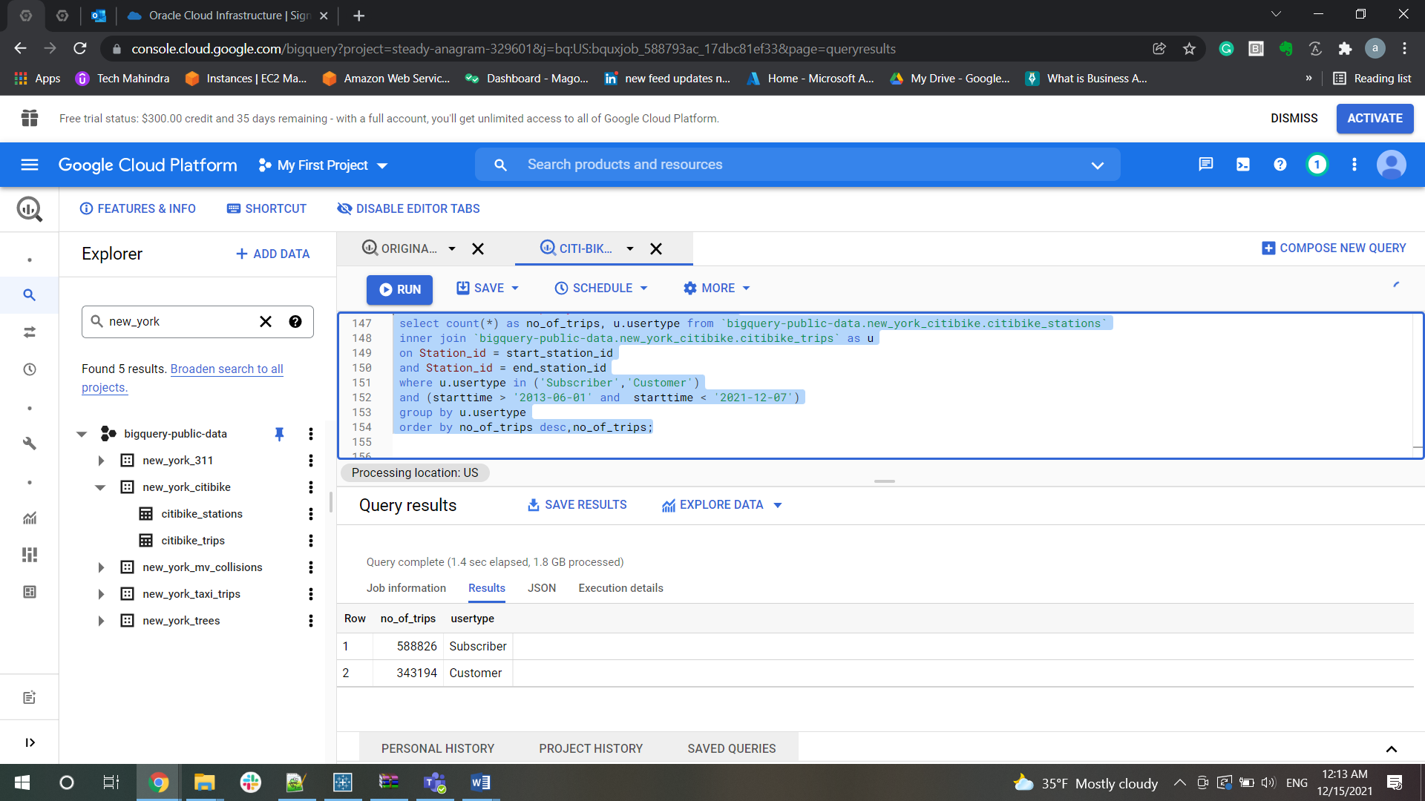

Further breakdowns (examples): time of day, weekday vs weekend, month

Month:

select count(*) as no_of_trips, u.usertype, EXTRACT(MONTH FROM starttime) as month from `bigquery-public-data.new_york_citibike.citibike_stations`

inner join `bigquery-public-data.new_york_citibike.citibike_trips` as u

on Station_id = start_station_id

and Station_id = end_station_id

where u.usertype in ('Subscriber','Customer')

and (u.starttime > '2013-06-01' and u.starttime < '2021-12-07')

group by u.usertype, u.starttime

order by no_of_trips desc,no_of_trips;

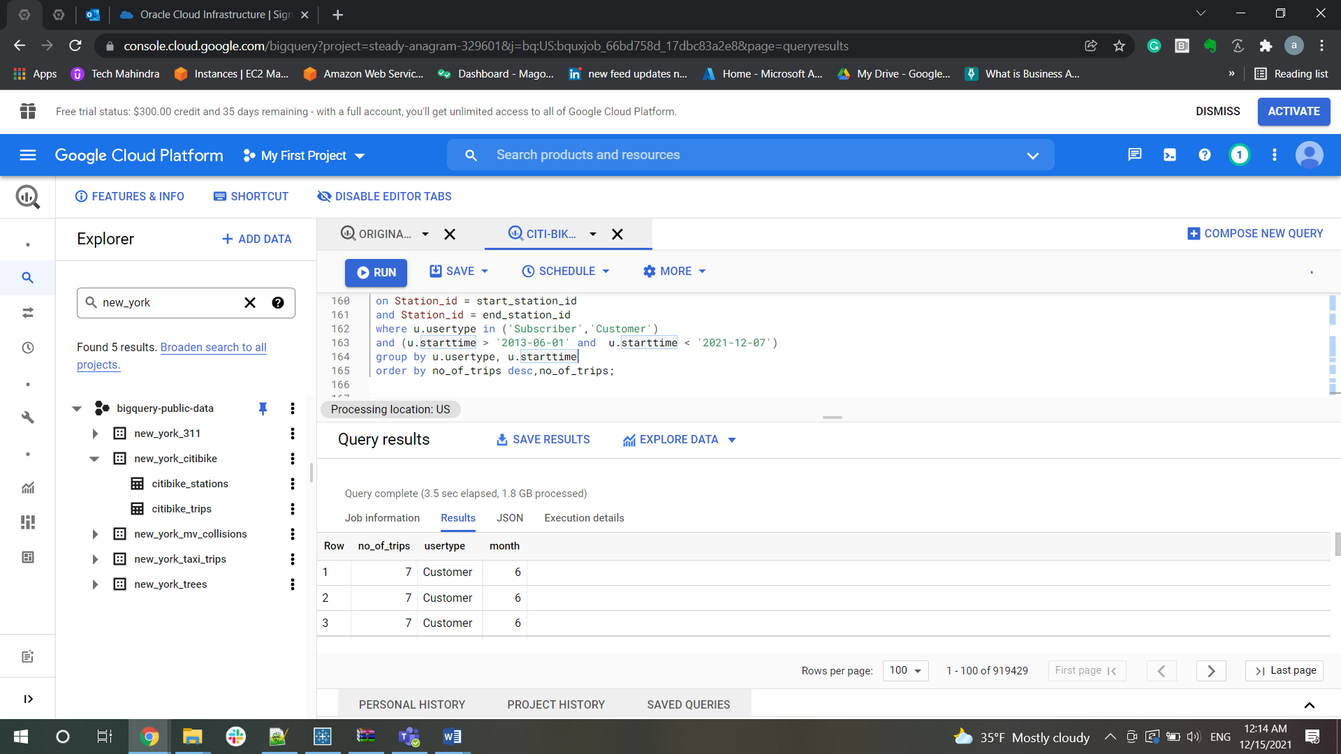

Time of the day:

select count(*) as no_of_trips, u.usertype, EXTRACT(time FROM starttime) as time from `bigquery-public-data.new_york_citibike.citibike_stations`

inner join `bigquery-public-data.new_york_citibike.citibike_trips` as u

on Station_id = start_station_id

and Station_id = end_station_id

where u.usertype in ('Subscriber','Customer')

and (u.starttime > '2013-06-01' and u.starttime < '2021-12-07')

group by u.usertype, u.starttime

order by no_of_trips desc,no_of_trips;

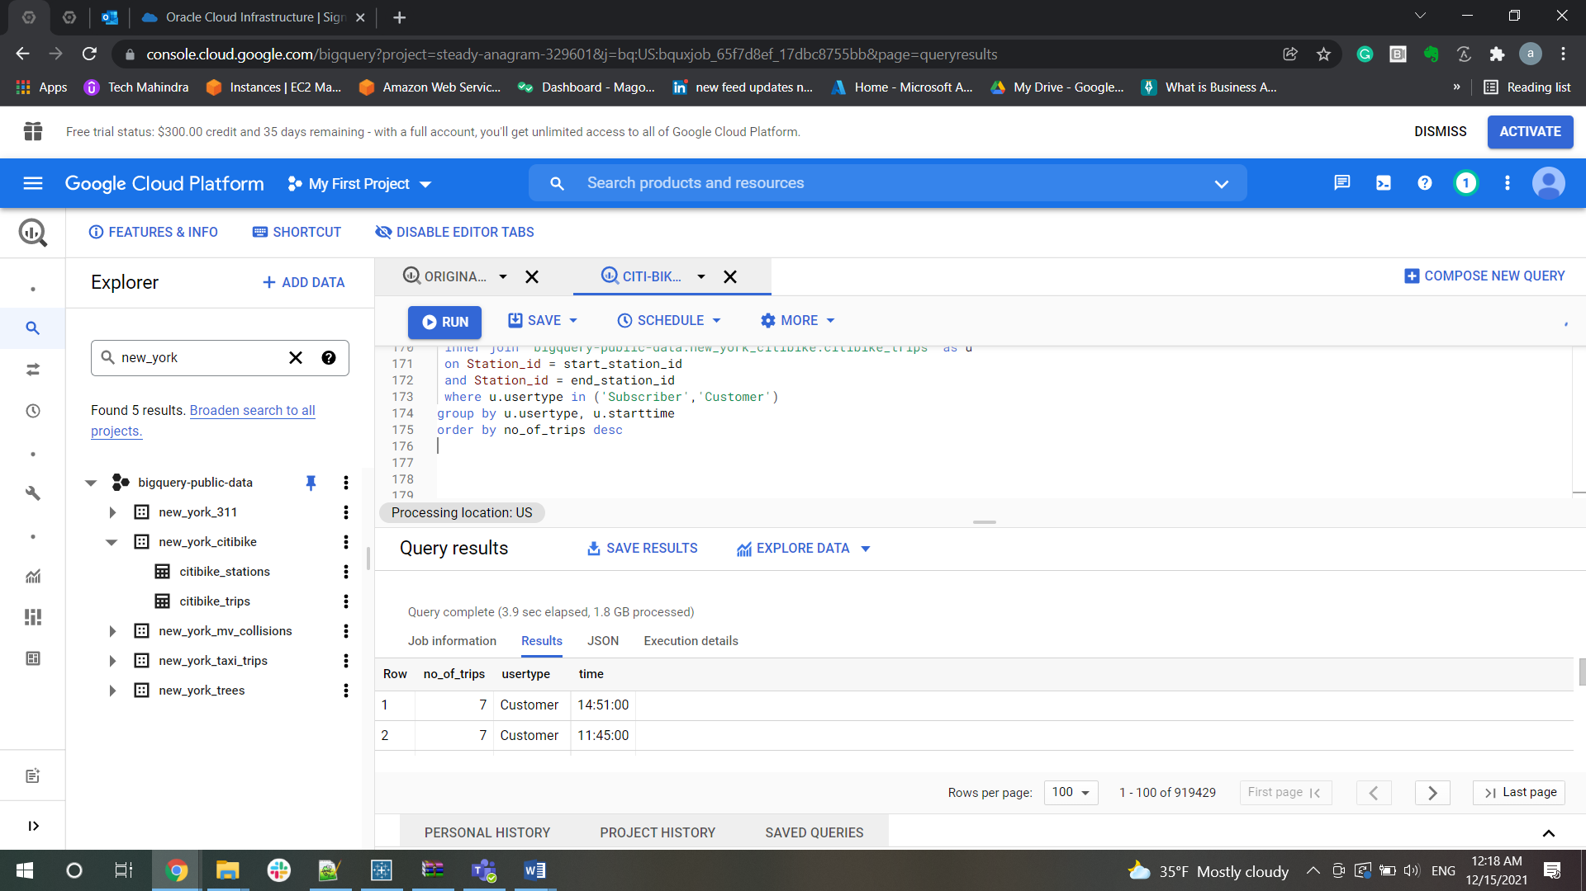

Weekday v/s weekends

 SELECT EXTRACT(YEAR from starttime) as year,

EXTRACT(DAY from starttime) as DAY,

CASE

WHEN EXTRACT(DAYOFWEEK from starttime) IN (6,7) THEN 'Weekend'

ELSE 'Weekday'

END AS columnnn,

avg(trips.countt) as avgtrip FROM (select count(*) as countt from `steady-anagram-329601.dmdd_final.citibike_trips`)as trips

cross join `steady-anagram-329601.dmdd_final.citibike_trips`

group BY year,day,columnnn;

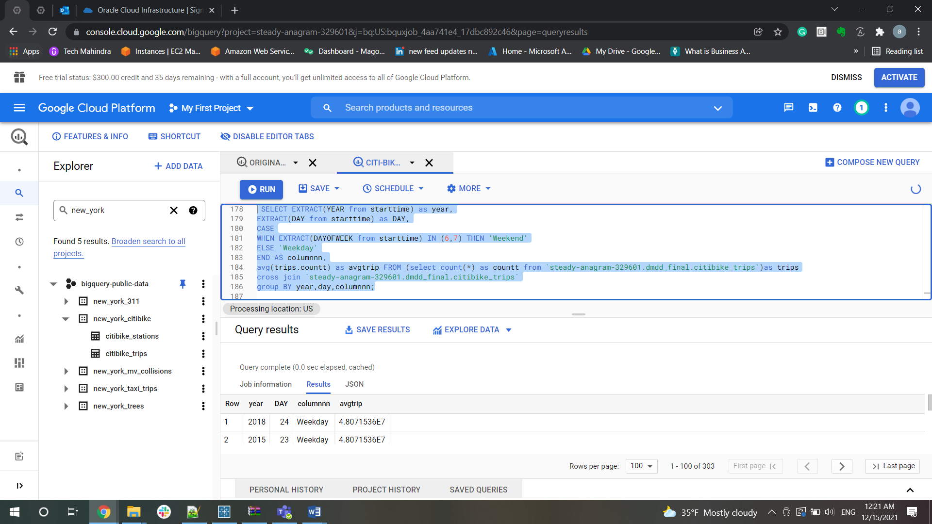

• Gender analysis  
▪ How many trips - female vs male

SELECT gender, count(station_id) as no_of_trips FROM

`bigquery-public-data.new_york_citibike.citibike_stations`

inner join `bigquery-public-data.new_york_citibike.citibike_trips`

on Station_id = start_station_id

group by gender

order by count(station_id) desc;

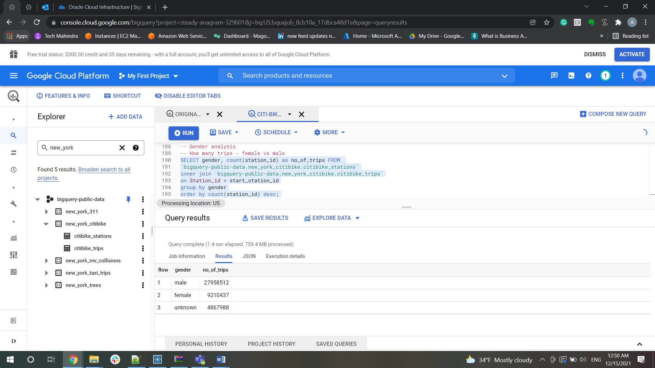

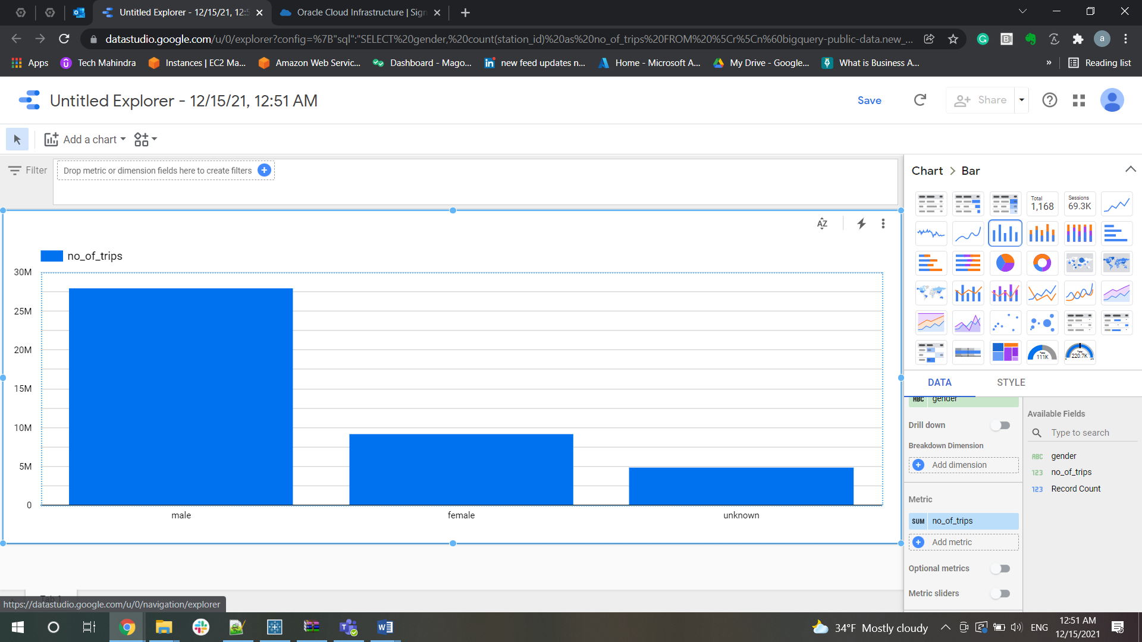

**As per analysis, Citi bikes has more male users than female users**

▪ Average length of trip - female vs male

SELECT gender, avg(tripduration / 60) as Average_Trip_Duration_in_Minutes

FROM `bigquery-public-data.new_york_citibike.citibike_trips`

group by gender

order by avg(tripduration / 60) desc;

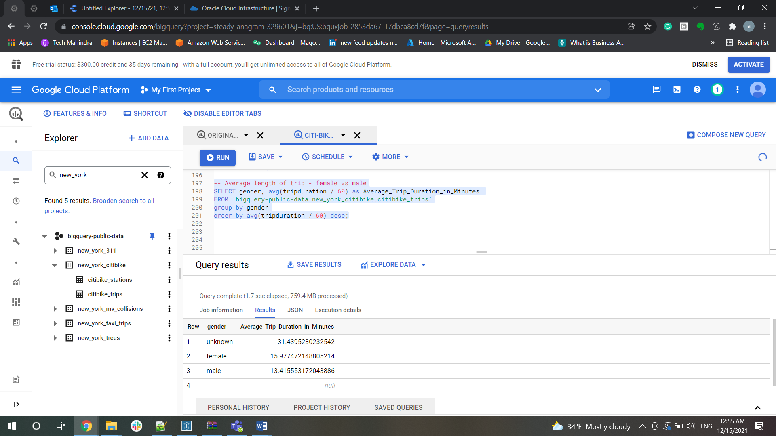

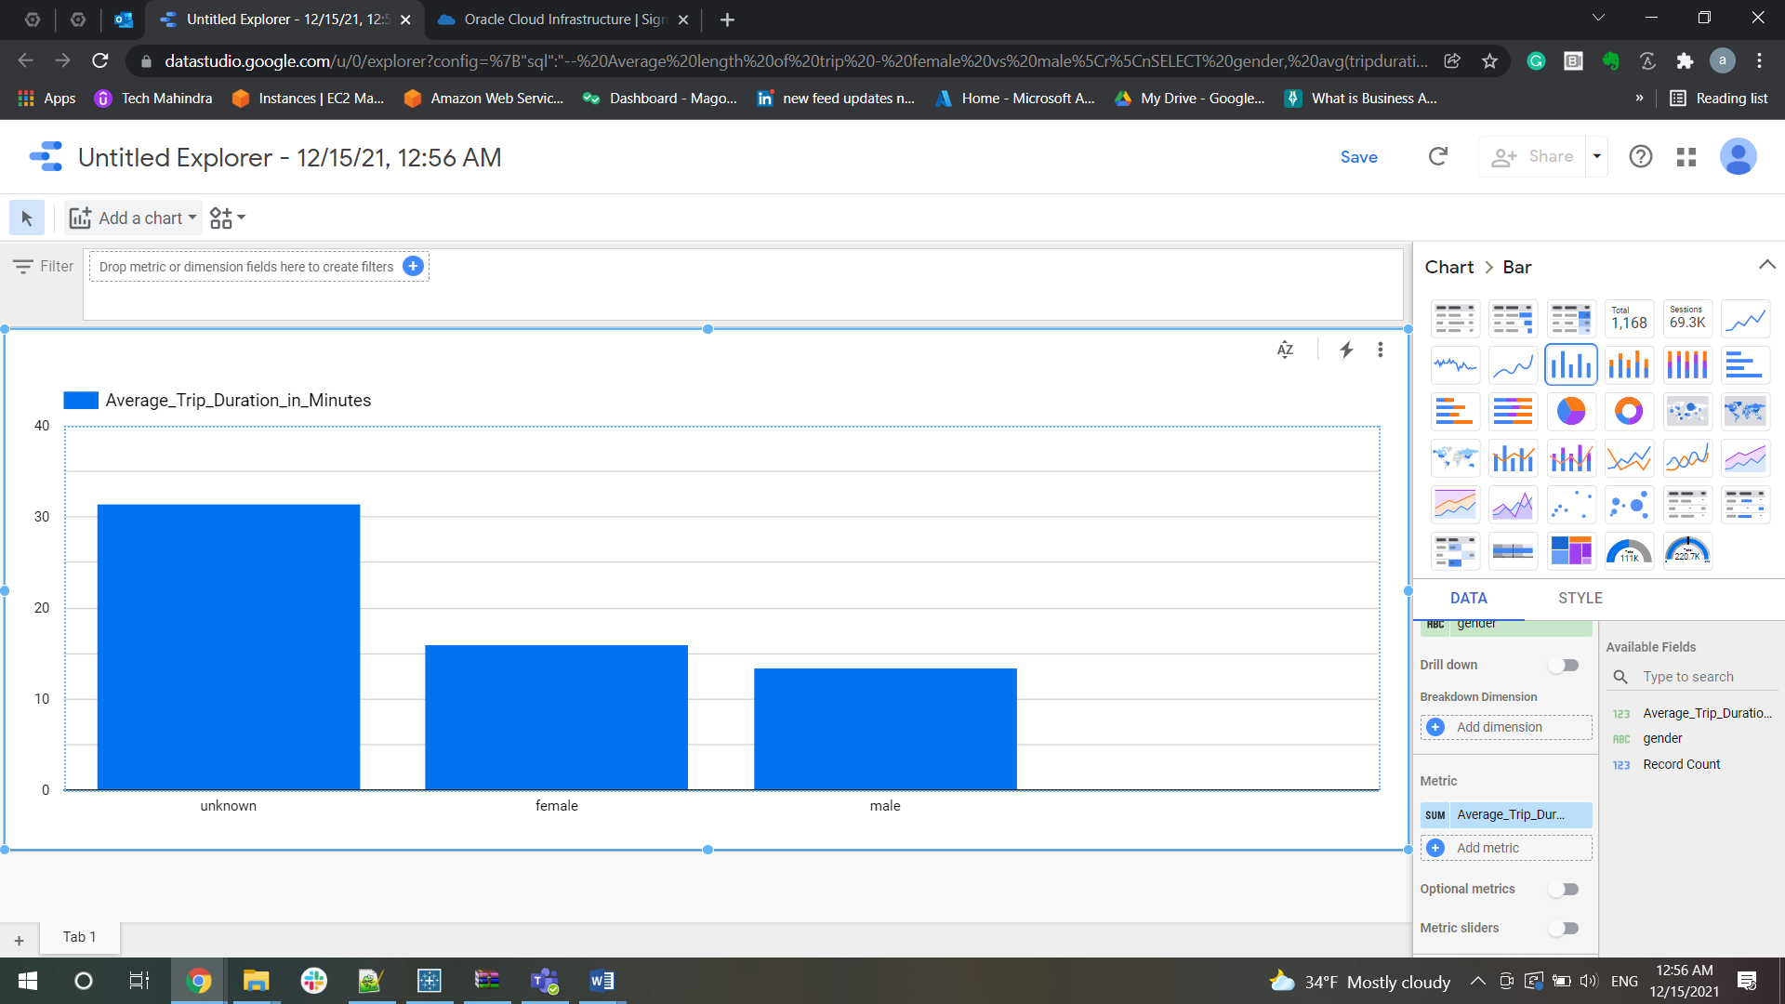

**Length of trip by female users were more than male users**

▪ Subscriber versus customer trips - female vs male

SELECT count(*) no_of_trips,gender, usertype

FROM `bigquery-public-data.new_york_citibike.citibike_trips`

group by gender,usertype

order by no_of_trips,usertype;

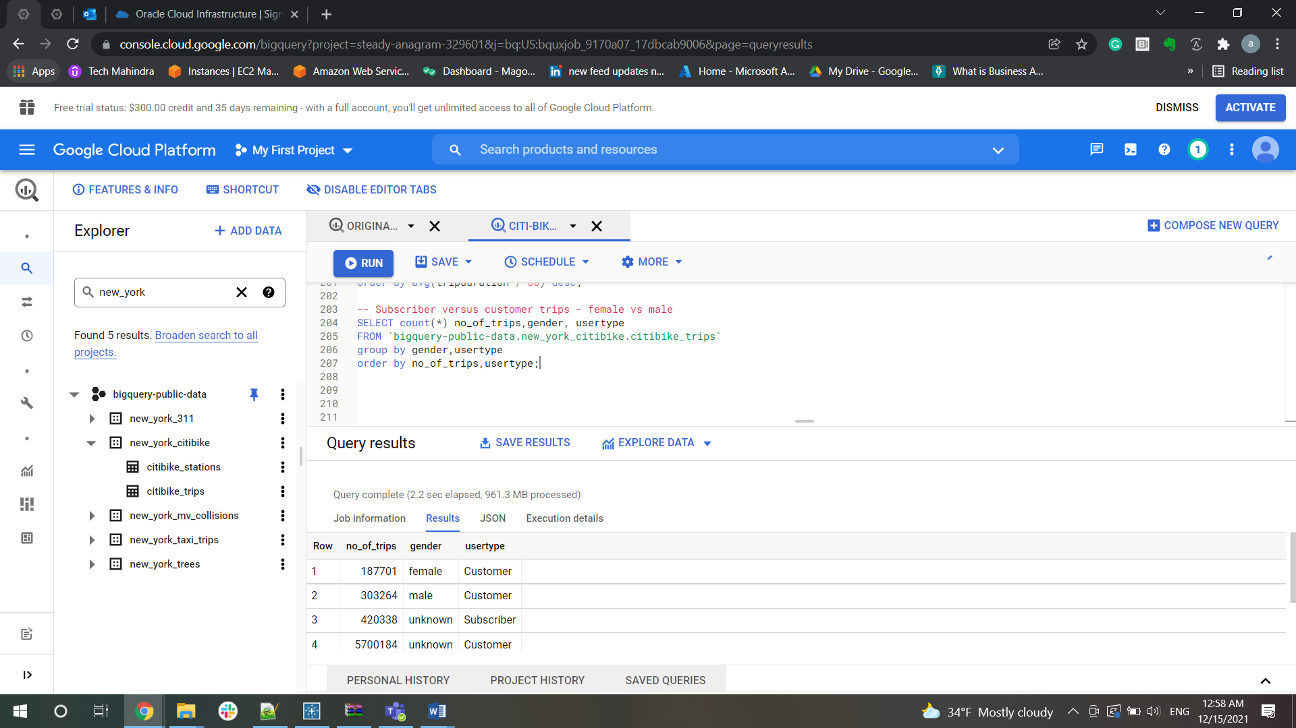

▪ Any trends from 2014 to 2020 regarding above

-- Any trends from 2014 to 2020 regarding above

SELECT  gender, count(station_id) as no_of_trips, EXTRACT(YEAR FROM starttime) AS year

FROM `bigquery-public-data.new_york_citibike.citibike_trips`

inner join `bigquery-public-data.new_york_citibike.citibike_stations`

on Station_id = start_station_id

group by  year, gender

order by count(station_id) desc;

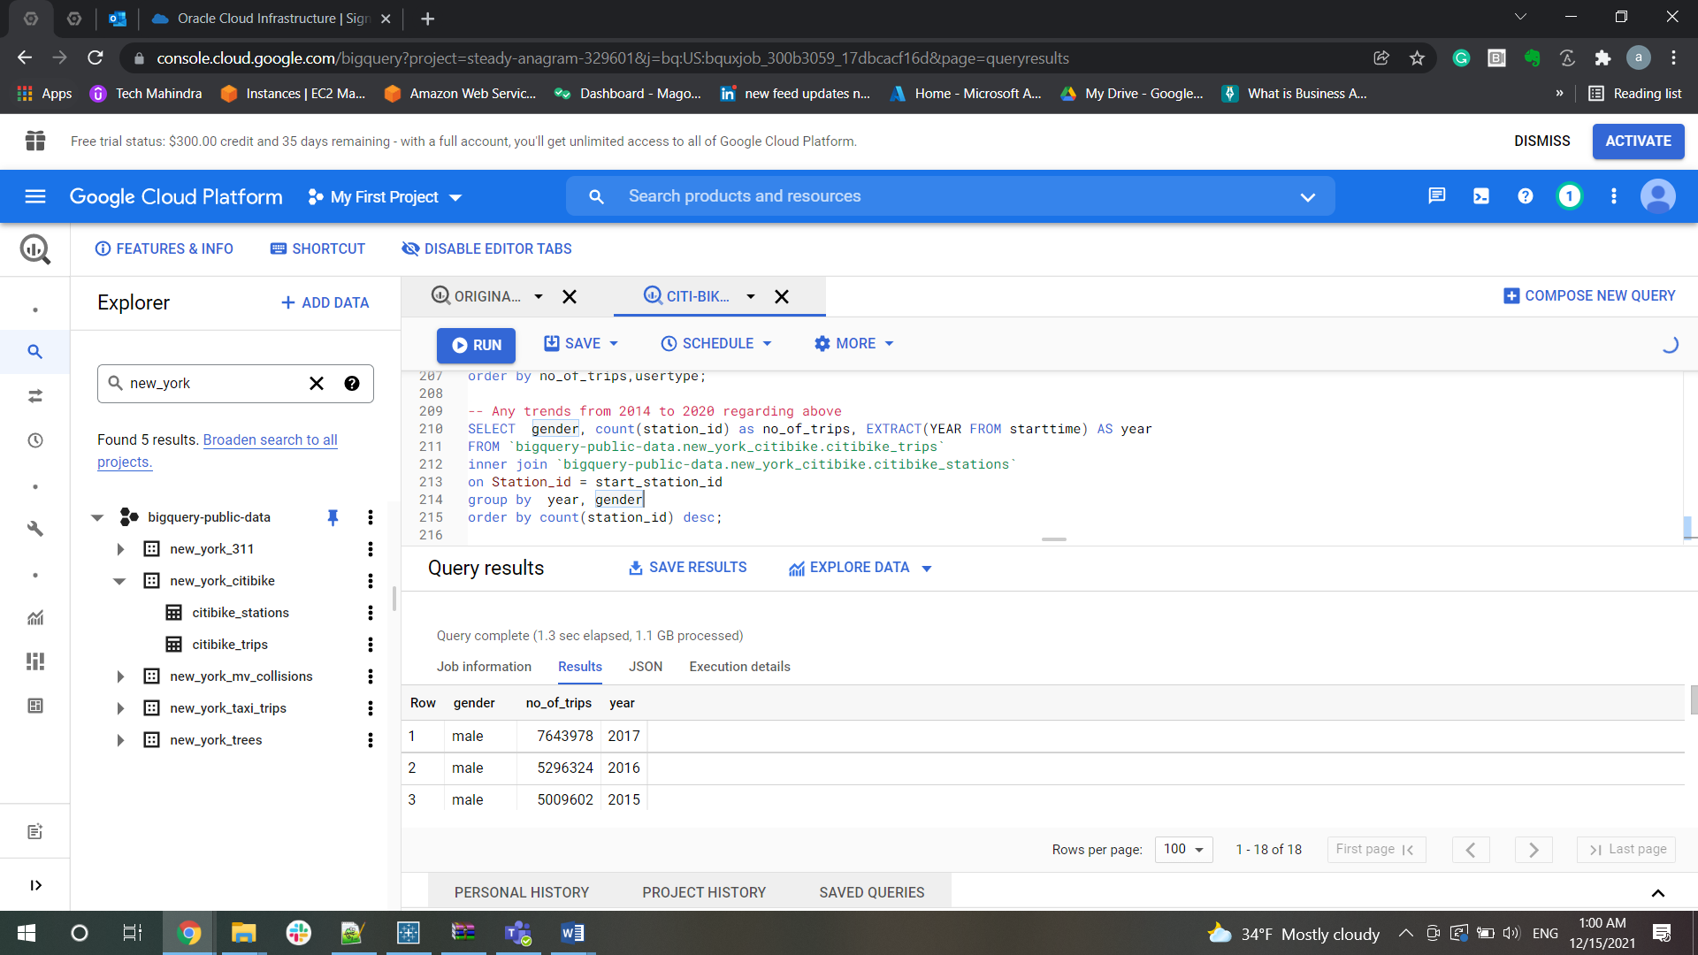

Age analysis (note: age at the time of the ride i.e., age is year of bike trip vs   
birth year)  
▪ What are the number of trips per age

SELECT count(*) as no_of_trips,(ride_year-birth)as age,birth,

ride_year from (select distinct(birth_year) as birth,

extract (ISOYEAR from starttime) as ride_year from `bigquery-public-data.new_york_citibike.citibike_trips`

group by birth,ride_year) group by age,birth,ride_year order by no_of_trips desc;

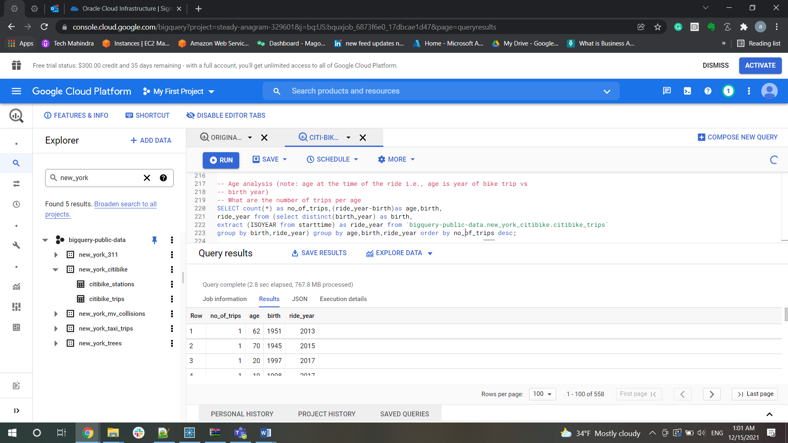

▪ Average length of trip per age

SELECT avg(tripduration / 60) as Average_Trip ,(ride_year-birth)as age,birth,

ride_year from (select distinct(birth_year) as birth,

extract (ISOYEAR from starttime) as ride_year,tripduration from `bigquery-public-data.new_york_citibike.citibike_trips`

group by birth,ride_year,tripduration) group by age,birth,ride_year;

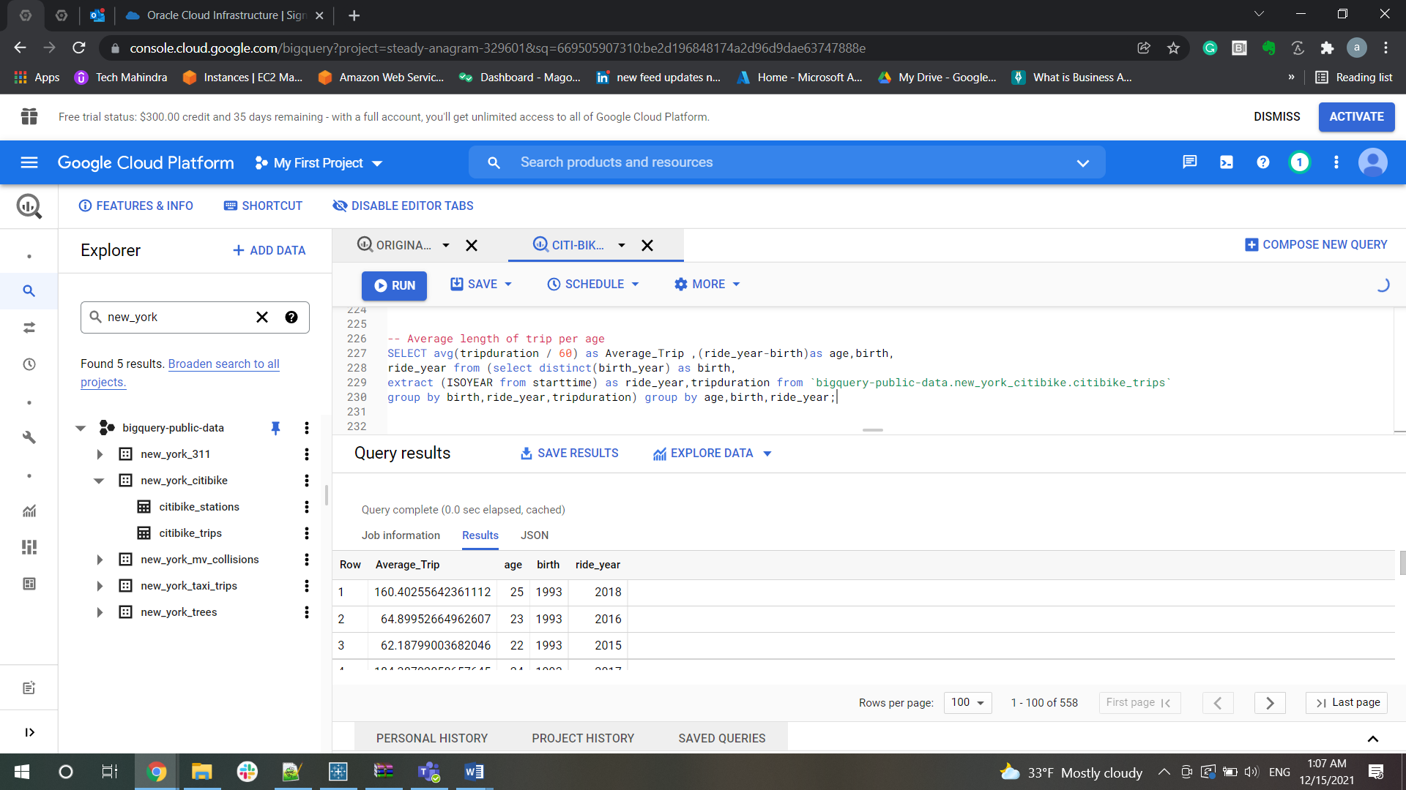

▪ Subscriber versus customer trips – per age

SELECT usertype,(ride_year-birth)as age,birth,

ride_year from (select distinct(birth_year) as birth,

extract (ISOYEAR from starttime) as ride_year,usertype from `bigquery-public-data.new_york_citibike.citibike_trips`

group by birth,ride_year,usertype) group by usertype,age,birth,ride_year;

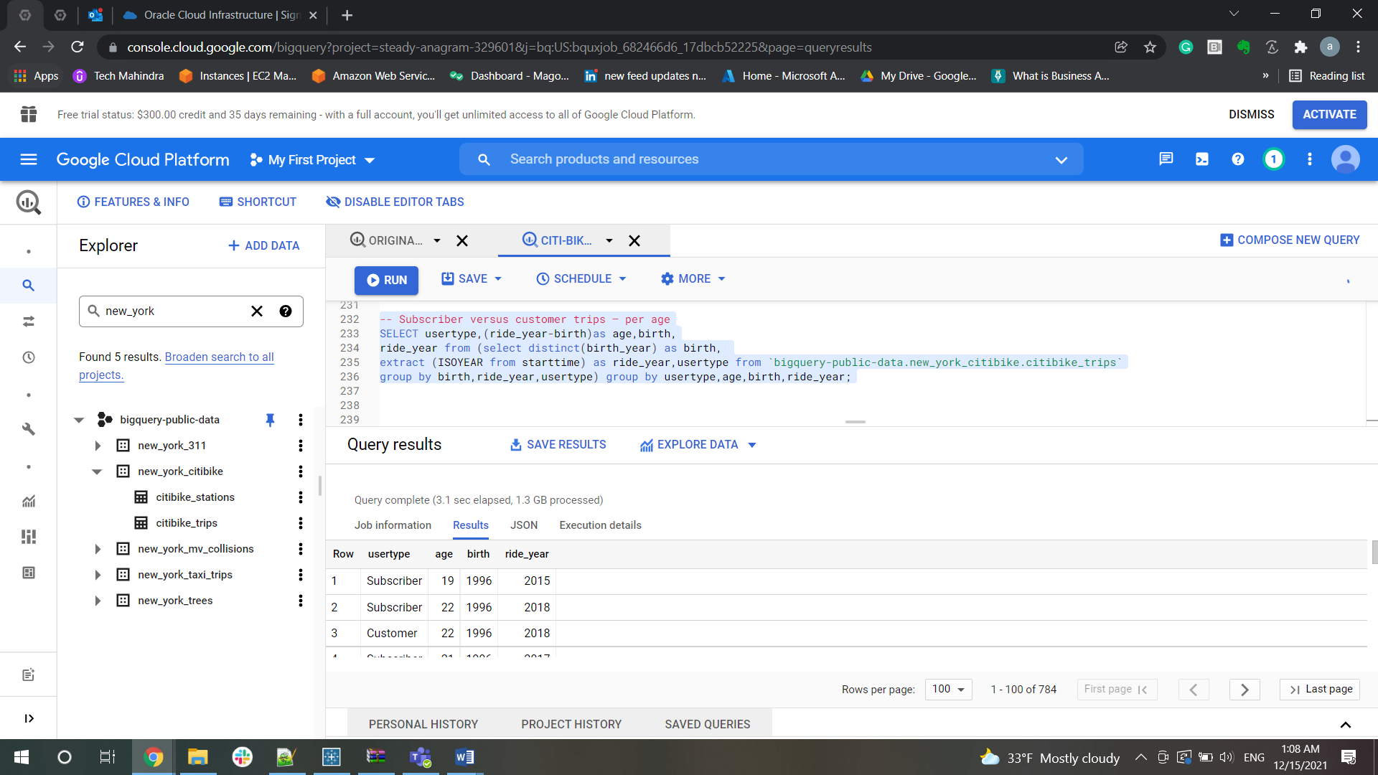

▪ Any trends from 2014 to 2020 regarding above

SELECT count(*) as no_of_trips,(ride_year-birth)as age,birth,

ride_year from (select distinct(birth_year) as birth,

extract (ISOYEAR from starttime) as ride_year from `bigquery-public-data.new_york_citibike.citibike_trips`

group by birth,ride_year) group by age,birth,ride_year order by no_of_trips desc;

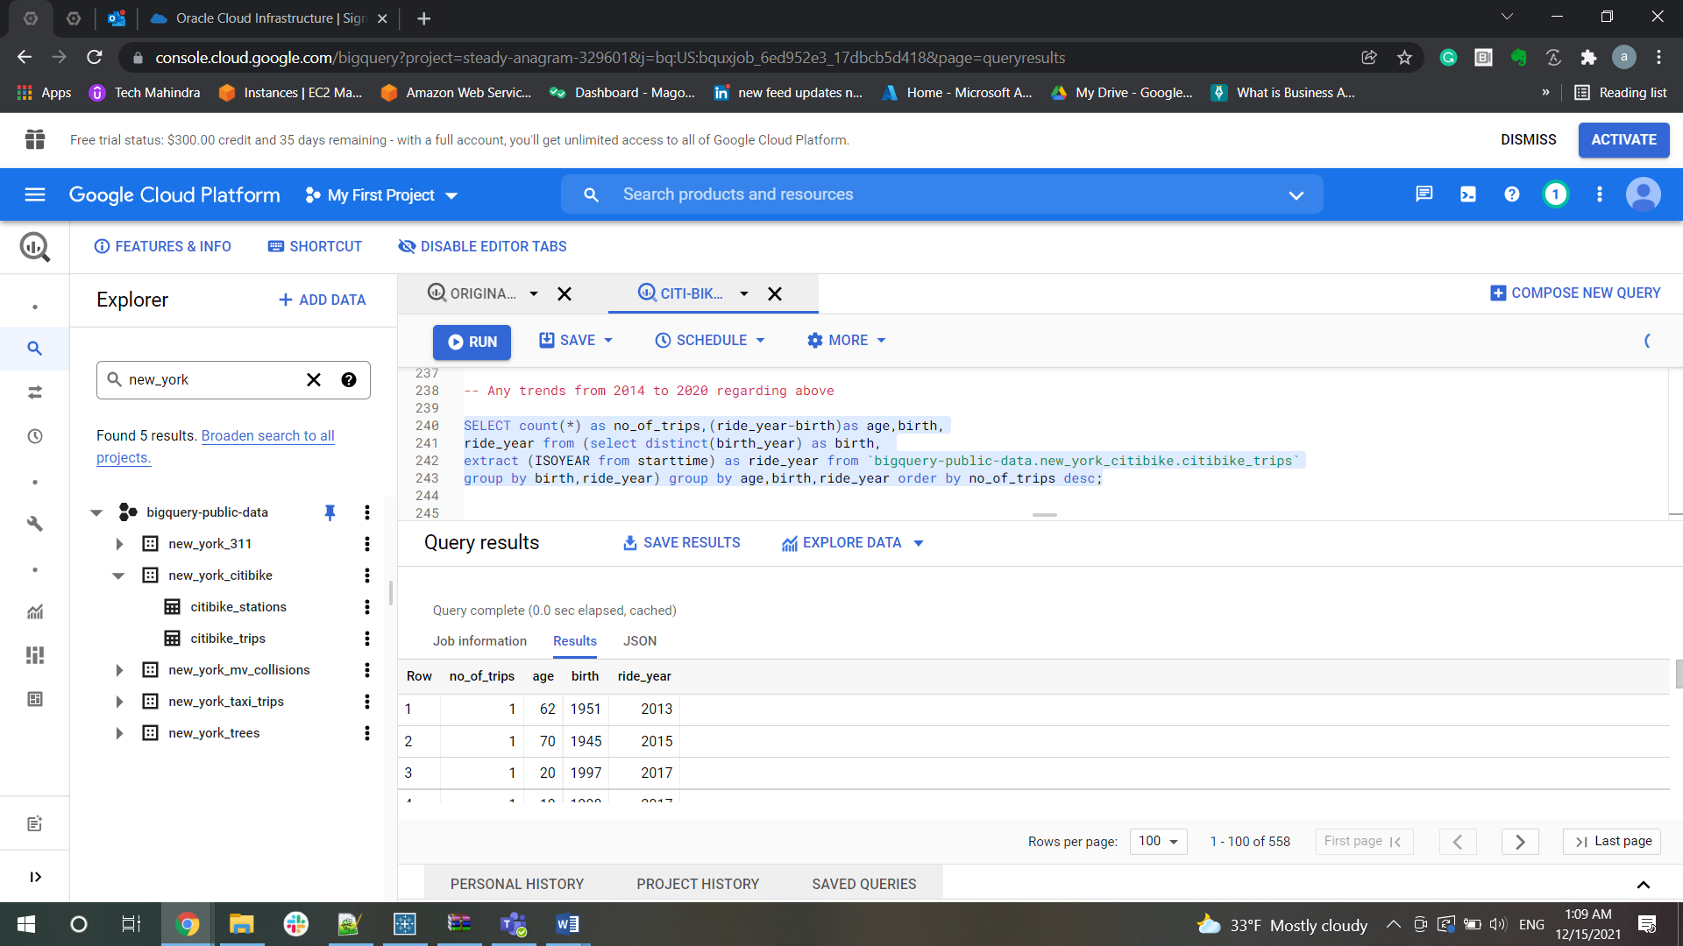

Bike Analysis  
• What are the top 5 bikes (bike id) for latest (full) year by  
▪ Total trips

select distinct(bikeid),count(*) as TotalTrips,

EXTRACT(YEAR FROM starttime) AS year from `bigquery-public-data.new_york_citibike.citibike_trips`

group by bikeid,year

order by year desc,TotalTrips desc limit 5;

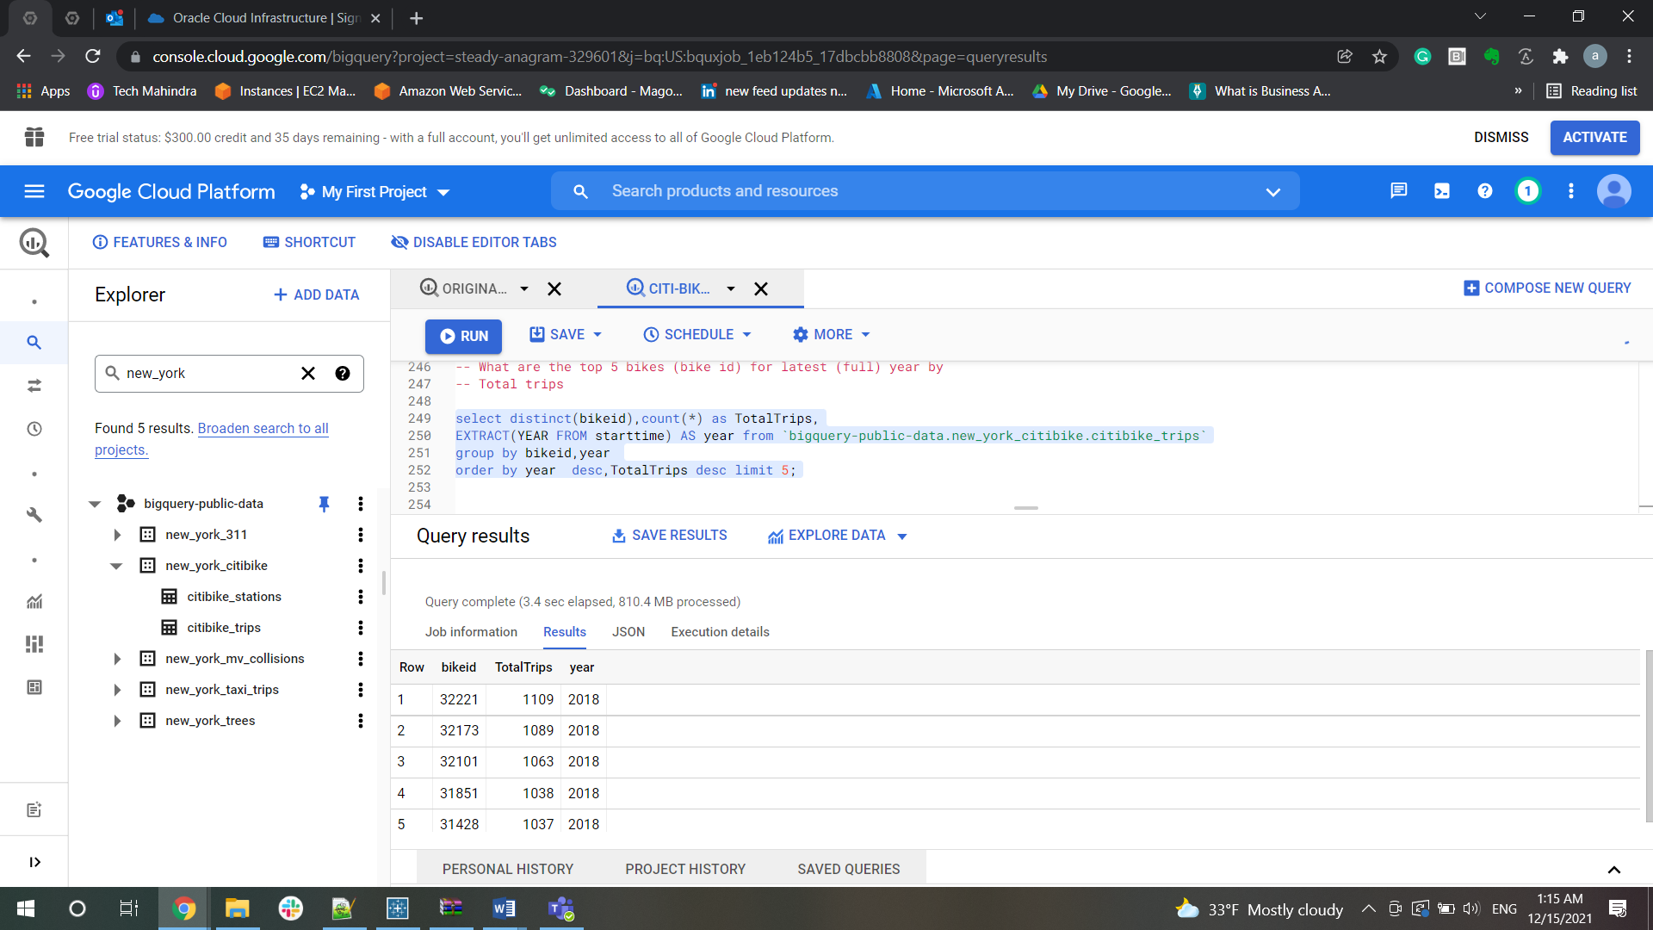

▪ Total time

select distinct(bikeid),EXTRACT(YEAR FROM starttime) AS year,

(tripduration/3600) TripDurationInHour from `bigquery-public-data.new_york_citibike.citibike_trips`

group by bikeid,year,TripDuration

order by year desc, TripDurationInHour desc limit 5;

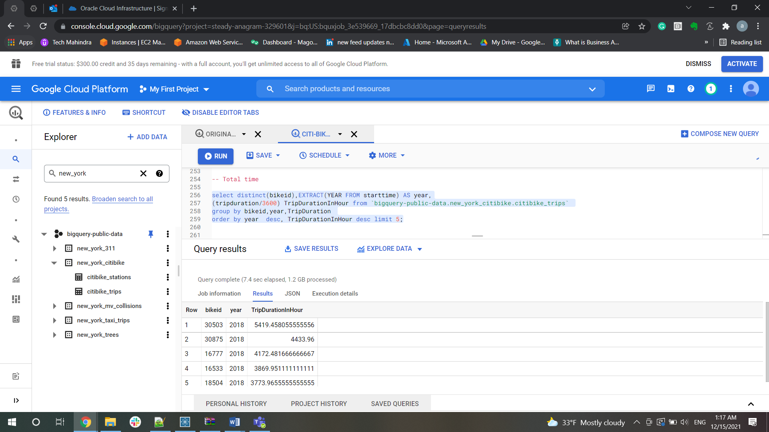

▪ Average trip time

select distinct(bikeid),EXTRACT(YEAR FROM starttime) AS year,

avg(tripduration / 60) as Average_Trip

FROM `bigquery-public-data.new_york_citibike.citibike_trips`

group by bikeid,year

order by year desc, Average_Trip desc limit 5;

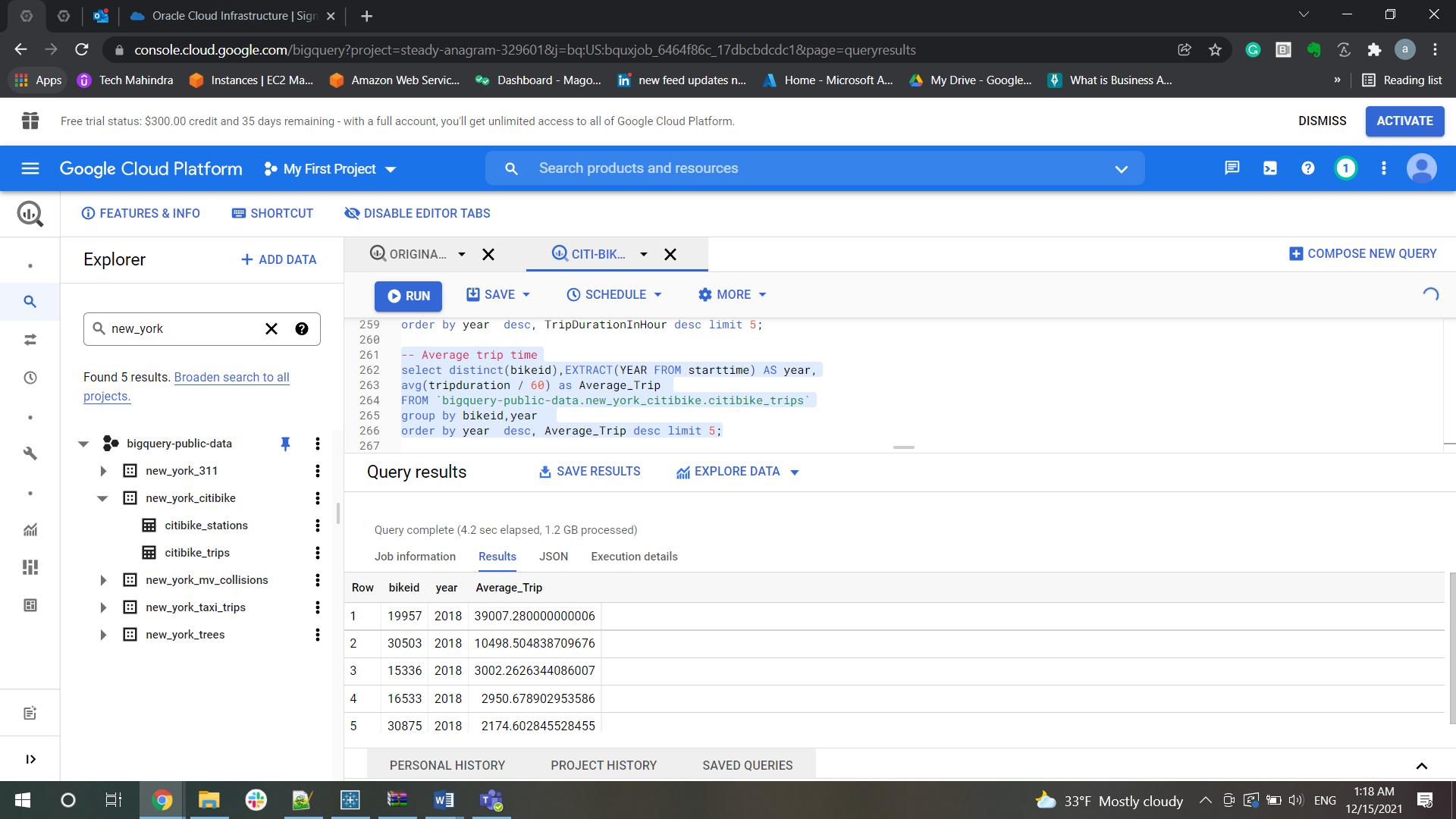

• For top bike (by total trips) create a history for the latest (full) year  
▪ Bike id

select distinct(bikeid),count(*) as TotalTrips,EXTRACT(YEAR FROM starttime) AS year

FROM `bigquery-public-data.new_york_citibike.citibike_trips`

group by bikeid,year

order by year desc,TotalTrips desc,bikeid desc;  
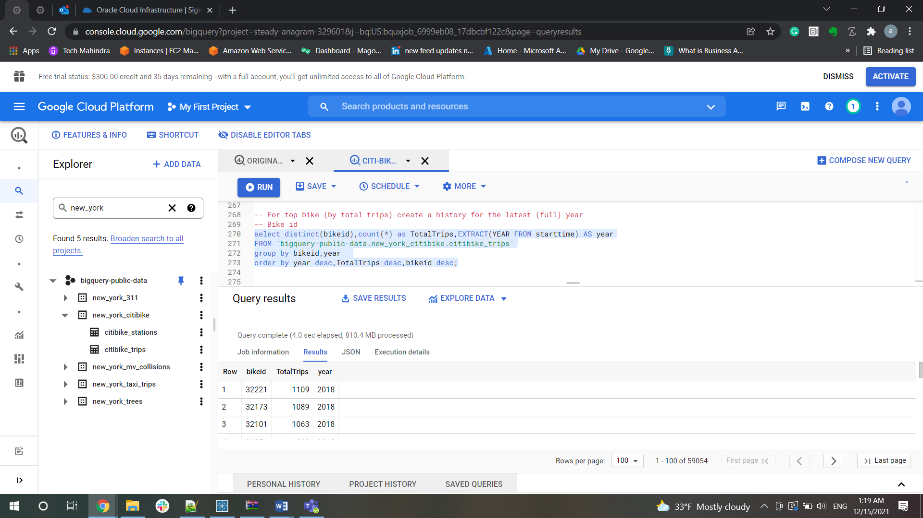

▪ Route (state and end location)

select distinct(bikeid),count(*) as TotalTrips,EXTRACT(YEAR FROM starttime) AS year,start_station_id,end_station_id

FROM `bigquery-public-data.new_york_citibike.citibike_trips`

group by bikeid,year,start_station_id,end_station_id

order by year desc,TotalTrips desc;

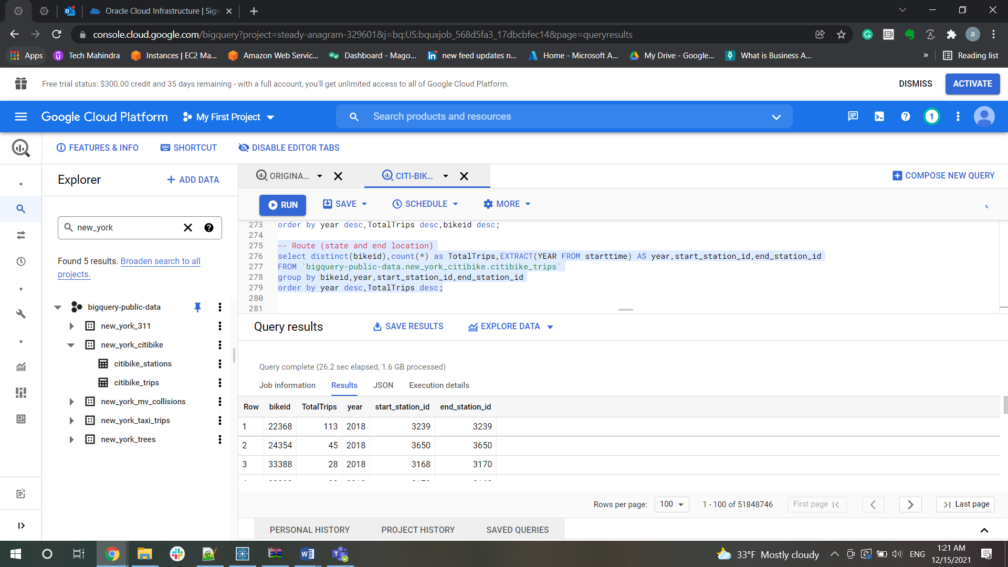

▪ Start time

select distinct(bikeid),count(*) as TotalTrips,EXTRACT(YEAR FROM starttime) AS year,starttime

FROM `bigquery-public-data.new_york_citibike.citibike_trips`

group by bikeid,year,starttime

order by year desc,starttime desc;

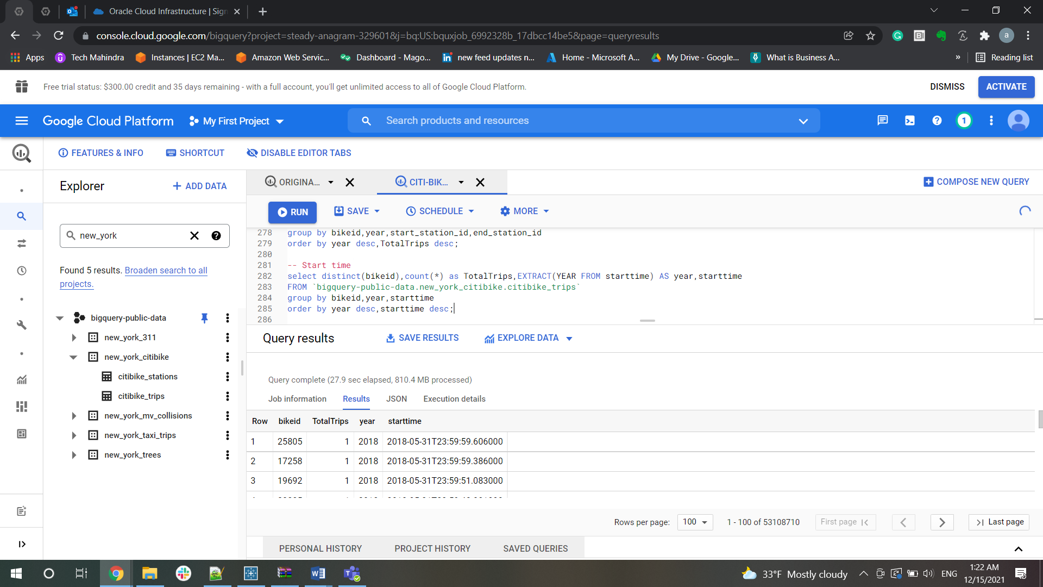

▪ Start location (id, longitude and latitude)

select distinct(bikeid),count(*) as TotalTrips,

EXTRACT(YEAR FROM starttime) AS year,start_station_id, start_station_latitude, start_station_longitude

FROM `bigquery-public-data.new_york_citibike.citibike_trips`

group by bikeid,year,start_station_id, start_station_latitude, start_station_longitude

order by year desc, start_station_id desc, start_station_latitude desc, start_station_longitude desc;

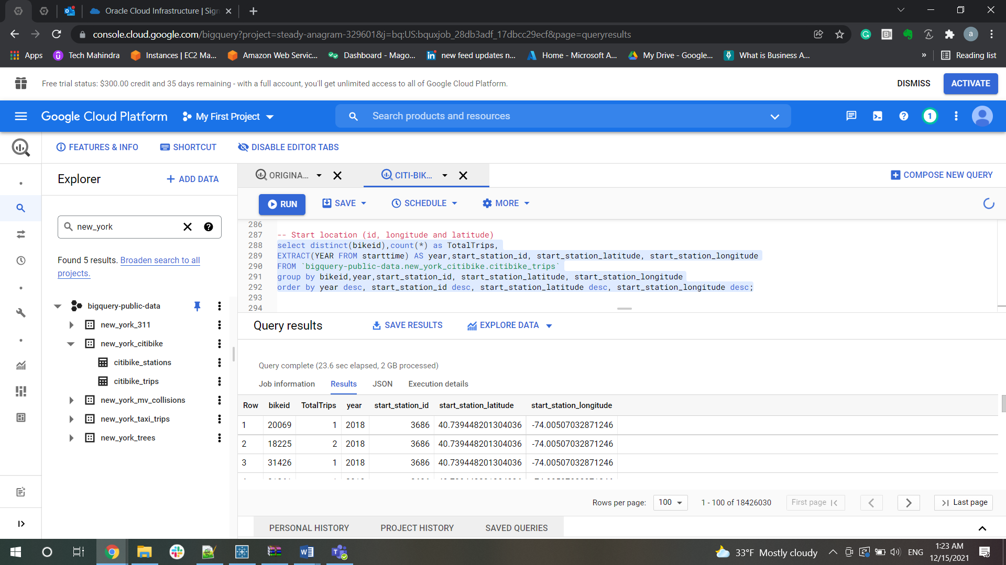

▪ Duration

select distinct(bikeid),count(*) as TotalTrips,

(tripduration/3600) TripDurationInHour,

EXTRACT(YEAR FROM starttime) AS year

FROM `bigquery-public-data.new_york_citibike.citibike_trips`

group by bikeid,year,TripDurationInHour

order by year desc,TripDurationInHour desc;

